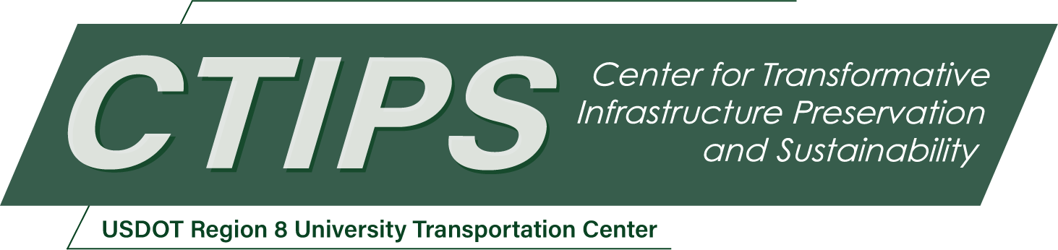

# Advanced Air Mobility to Enhance Freight Logistics and Preserve Road Condition

*CTIPS-001 – UTC Project Information*

|  |  |
| --- | --- |
| **Recipient/Grant Number:** | North Dakota State University  Grant No. 69A3552348308 |
| **Center Name:** | Center for Transformative Infrastructure Preservation and Sustainability |
| **Research Priority:** | Preserving the Existing Transportation System |
| **Principal Investigator(s):** | Raj Bridgelall |
| **Project Partners:** | USDOT, Office of the Assistant Secretary for Research and Technology – $168,344  North Dakota LTAP – $83,344  Transportation Learning Network – $60,000  Northern TTAP – $25,000 |
| **Total Project Cost:** | $336,688 |
| **Project Start and End Date:** | 3/25/2024 to 3/24/2026 |

## Project Description

The emerging field of Advanced Air Mobility (AAM) presents myriad opportunities for disrupting traditional modes of transport, including passenger travel to cargo logistics. Moving cargo by air instead of by truck in significant volumes can preserve road condition and reduce highway crash exposure. However, its path to full-scale adoption is fraught with regulatory, market, and logistical challenges. This report presents a refined understanding of AAM's complexities and its potential for transformative impact, particularly to reduce the impacts on surface transportation degradation. The research employs data-driven methodologies, machine learning algorithms, and Geographic Information System (GIS) techniques to explore the landscape of AAM. These studies aim to reveal the crucial role of regulatory frameworks and economic progress in AAM adoption, the importance of accurate market forecasting, and the value of identifying key commodity and geographical targets for cargo drones. Additionally, this study highlights the potential of AAM in safely transporting goods to rural communities without heavy trucks traveling on highways. The successful integration of AAM into global transportation systems requires a multi-disciplinary and multi-stakeholder approach. This study highlights the need for future research to build on this work to scale and optimize AAM technologies to meet the varying needs of nations and industries worldwide.

## USDOT Priorities

This research aligns with the U.S. DOT's goals of economic strength and global competitiveness by supporting the efficient evolution of transportation systems to accommodate AAM innovations. This research will lead to enhanced service life of existing infrastructures by transferring ground traffic to air, promoting economic competitiveness.

## Outputs

The PI will utilize the project findings and models to produce publications and outreach to guide real world adoption. Insights from the project will inform AAM use cases, business development, and further studies for practical deployments, tailored to unique needs of the state. Students will gain expertise in technology development to enhance business practices and logistical operations. The team will utilize traditional methods such as journal papers, conference presentations, project reports, web page postings, and other marketing or outreach materials. In addition, the team will engage stakeholders throughout the project to review intermediate findings and to suggest future research directions.

## Outcomes/Impacts

The research will yield an initial foundational guide for AAM adoption, outlining the technological, economic, and regulatory landscapes. This guide will inform an actionable deployment roadmap, support educational initiatives, and support technology transfer towards AAM integration into North Dakota's multimodal transportation ecosystem.

## Final Report

Upon completion, the final report link will be added to the [project page on the CTIPS website](https://www.ctips.org/projects/details.php?id=599).