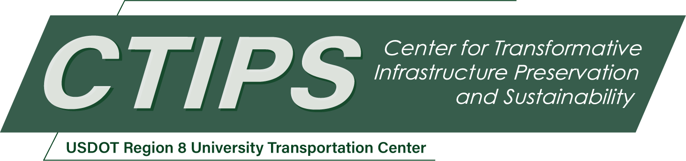

# Rapid and Low-Cost Monitoring of Bridge Scour Using an Unmanned Underwater Drone

*CTIPS-003 – UTC Project Information*

|  |  |
| --- | --- |
| **Recipient/Grant Number:** | North Dakota State University, Fort Lewis College  Grant No. 69A3552348308 |
| **Center Name:** | Center for Transformative Infrastructure Preservation and Sustainability |
| **Research Priority:** | Preserving the Existing Transportation System |
| **Principal Investigator(s):** | Yiyan Li, Ph.D. |
| **Project Partners:** | USDOT, Office of the Assistant Secretary for Research and Technology – $75,371  Fort Lewis College – $75,371 |
| **Total Project Cost:** | $150,742 |
| **Project Start and End Date:** | 4/23/2024 to 4/22/2026 |

## Project Description

The project aims to develop a cost-effective unmanned underwater drone (UUD) and sensing system for swift bridge scour assessment. It aims to surpass stationary sonar systems in cost and flexibility while providing superior accuracy compared to vessel-based systems. Both hardware and software will be open source, facilitating widespread use and collaboration. Knowledge will be shared via GitHub and integrated into engineering curricula. A novel circular maneuvering controller will be documented and published, encouraging replication. Enhancements include integrating sonar and a distance sensor for circular maneuvering around bridge piers, generating real-time 3D depth maps to overcome existing method limitations. This innovative approach addresses cost, resolution, and operational issues, offering a more efficient solution for scour mapping. The project emphasizes accessibility, education, and practical application, with potential benefits for infrastructure monitoring and safety.

## USDOT Priorities

The proposed project holds great relevance to the preservation and enhancement of existing transportation infrastructure, with a specific focus on bridges. Addressing the critical issue of scour, a natural threat to bridge foundations, the project is poised to contribute significantly to the long-term structural integrity of these essential components of transportation networks. By concentrating efforts on the 158 scour critical bridges identified by the Colorado Department of Transportation (CDOT), the project aids in identifying vulnerable structures, facilitating prioritized maintenance efforts, and efficient resource allocation. A key aspect of the proposal is the introduction of a cost-effective solution for scour assessment, leveraging an autonomous UUD. This innovative approach not only provides a scalable method for monitoring numerous bridges but also mitigates financial constraints associated with traditional monitoring systems. The UUD, equipped with sonar and distance sensors, enables real-time assessments of riverbed conditions around bridge piers. This capability ensures timely identification of potential scour concerns, allowing for prompt intervention and maintenance actions. The open-source nature of both hardware and software components fosters collaboration and knowledge sharing within the engineering community, facilitating the acceleration of effective scour monitoring technologies. Additionally, the documentation of research methods, outcomes, and educational modules serves as a valuable resource for transportation authorities, engineers, and researchers seeking best practices in infrastructure preservation.

## Outputs

The team will develop comprehensive research papers that detail methodologies, findings, and outcomes is the initial step, followed by publishing these papers in reputable journals to make them accessible to the global research community. Embracing open-source principles, project codes, algorithms, and software will be shared on platforms like GitHub, fostering collaboration and contributions from researchers and developers worldwide.

Collaborative research initiatives with institutions and universities will be pursued to leverage shared expertise and resources. Integration with educational curricula involves working with institutions to incorporate UUD development modules and offering training sessions for educators.

Establishing a framework for long-term support, updates, and maintenance guarantees continuous accessibility and relevance, aligning with the overarching goal of fostering widespread adoption and application of the UUD technology in bridge scour monitoring for enhanced infrastructure resilience and safety.

## Outcomes/Impacts

In the first year, we will develop and assess the control system and the UUD capable of executing a spiral rotation around the pier. The methods and outcomes will be shared on GitHub, and the research particulars will be documented in a research article for publication. Moving into the second year, we will incorporate field testing and implement an updated system for a second publication. Each year, one undergraduate research assistants will be recruited to contribute to the project. Additionally, five engineering students will join a senior capstone team, integrating the project into their senior projects. We foresee training at least seven undergraduate researchers in UUD design, bridge maintenance, software development, and general engineering design skills, enabling them to actively participate in the research project. Furthermore, we anticipate the development of ten educational modules within the first two years of the project—five focusing on UUD development and related hardware and software design, and five concentrating on field testing and data processing. To engage K-12 students during field testing, at least two workshops or tours will be organized. The engineering department at Fort Lewis College regularly welcomes local K-12 students for tours throughout the academic year and college-wide open houses. Additionally, the team will host a booth to showcase this technology twice a year during these events, disseminating knowledge to visitors.

## Final Report

Upon completion, the final report link will be added to the [project page on the CTIPS website](https://www.ctips.org/projects/details.php?id=601).