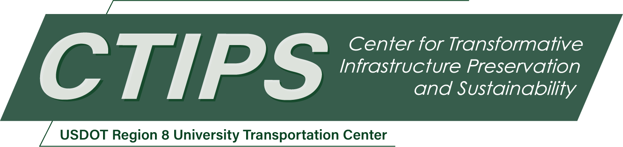

# Data-Driven Inspection Planning for Utah Culverts Using Federated Learning

*CTIPS-005 – UTC Project Information*

|  |  |
| --- | --- |
| **Recipient/Grant Number:** | North Dakota State University, University of Utah  Grant No. 69A3552348308 |
| **Center Name:** | Center for Transformative Infrastructure Preservation and Sustainability |
| **Research Priority:** | Preserving the Existing Transportation System |
| **Principal Investigator(s):** | Abbas Rashidi, Ph.D. |
| **Project Partners:** | USDOT, Office of the Assistant Secretary for Research and Technology – $50,000  Utah Department of Transportation – $50,000 |
| **Total Project Cost:** | $100,000 |
| **Project Start and End Date:** | 5/6/2024 to 5/5/2026 |

## Project Description

As transportation agencies increasingly adopt cutting-edge data analytics to refine infrastructure management strategies, the role of condition prediction models is becoming more critical. These models are pivotal in optimizing maintenance budgets, especially for underrepresented infrastructures like culverts, which have been neglected in the past. Similarly, due to the lack of a comprehensive culvert management system, the Utah Department of Transportation (UDOT) faces significant challenges in inspecting and maintaining culverts. Therefore, this study proposed a data-driven approach using federated learning to enhance Utah's culvert management. Since Utah's culvert dataset was limited, we expanded it by collecting data from several other state DOTs. However, to address data privacy concerns, we employed federated learning approach. This innovative technique avoids direct data sharing. Instead, each DOT trains a local model on its own data, and only the updated model parameters are shared with UDOT. This allows us to leverage the collective knowledge of multiple DOTs while ensuring robust data security. Our findings highlight the efficacy of the proposed federated learning-based models in enhancing prediction accuracy while ensuring data privacy and reducing data transmission overheads.

## USDOT Priorities

Primary strategic goal: Economic Strength and Global Competitiveness

UDOT is tasked with compiling a list of capital improvement projects to secure the necessary funding, likely within the two or three years, to ensure investments are made at the most opportune time. In other words, recommendations for culvert inspection or maintenance actions (repair, rehabilitation, and replacement) need to be assessed and prioritized while adhering to budgetary allocations and minimizing risks and costs associated with failure. The proposed approach aims to optimize the yearly allocation of maintenance budgets by identifying culverts that require inspection, rehabilitation, or replacement. At the network level, the allocation of funds is determined based upon an initial budget. Furthermore, the optimum sequential path in the annual decision-making process may be determined using a combination of operations research tools.

The system offers a cost-efficient method for assessing culvert conditions and prioritizing maintenance tasks in situations with limited highway infrastructure data. The system also can help in providing an estimate of the minimum annual budget needed over a specified planning period to maintain or enhance the total value of the assets. Furthermore, it supports project-level prioritization regarding inspections, rehabilitations, replacements, or inaction when resources are scarce. Efficient transportation infrastructure keeps workers and goods moving, fostering economic activity and job creation. Furthermore, by prioritizing preventative maintenance, UDOT reduces the need for costly emergency repairs and minimizes environmental disruptions often associated with culvert failure.

## Outputs

The technology transfer process for this project will take place through three major channels: 1) publishing (presenting) research results in scholarly journals (peer-reviewed journal articles or conference papers); 2) direct interactions and with UDOT personnel through training sessions and workshops as the potential end-users for the results of this study, and 3) developing a prototype platform for potential commercialization and integrating it into Atom software as a final product offering.

## Outcomes/Impacts

The expected outcomes for this project will include the following items: a federated learning-based predictive model, which increases the performance of a centralized model in predicting the future condition of culverts while complying with privacy concerns. In addition, we will provide a data-driven prioritization approach for inspecting culverts with limited data availability. This framework will be implemented on a GIS platform or Atom software.

It is also necessary to mention that the outcomes of this project will be discussed and evaluated by UDOT personnel as the practitioners who will benefit from this project.

## Final Report

Upon completion, the final report link will be added to the [project page on the CTIPS website](https://www.ctips.org/projects/details.php?id=603).