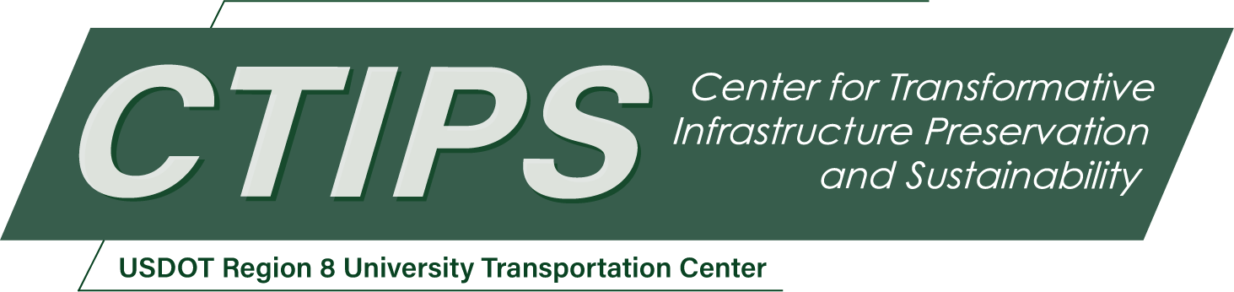

Transportation Infrastructure Electrification Certificate Program
CTIPS-006 – UTC Project Information
Recipient/Grant Number: | North Dakota State University, University of Utah  Grant No. 69A3552348308
Center Name: | Center for Transformative Infrastructure Preservation and Sustainability
Research Priority: | Preserving the Existing Transportation System
Principal Investigator(s): | Xiaoyue Cathy Liu, Ph.D., P.E.
Project Partners: | USDOT, Office of the Assistant Secretary for Research and Technology – $50,000  Utah System of Higher Education – $50,000
Total Project Cost: | $100,000
Project Start and End Date: | 5/6/2024 to 5/5/2026

Project Description
The future of electrified transportation infrastructure operates at the nexus of several critical industries (such as Transportation, Building, Power/Energy, Information Technology, Data Science, and Economics) that have historically operated independently, and the ever-increasing overlap among them has little to no strategic coordination. A coherent understanding of these complex interactions is required to capture and harness convergence across these industries and scientific communities and to reshape forever the future. The Transportation Infrastructure Electrification Certificate Program will be a collaborative effort pulling domain experts from the aforementioned disciplines and to train graduate students by applying knowledge from across numerous domains to tackle one of the most significant social issues of our time, preparing them to adapt to an increasingly interdisciplinary world, as well as increasing awareness of the many system-level impacts issues permeating life in the U.S. and elsewhere.
The program’s vision is to create entirely new lines of thinking on how city, highway, electric grid infrastructures are designed, how vehicles and operators interact with those systems, and how to integrate private sector partners and public resources in the human interface of planning, economics, and policy.

USDOT Priorities
The proposed project will address the USDOT strategic goal of economic strength and global competitiveness, and will also address climate and sustainability as the secondary strategic goal.
The evolving U.S. energy and transportation systems present both opportunities and challenges in maintaining operational reliability, efficiency, and system resilience. The integration of distributed energy resources, advanced vehicle technologies, and intelligent infrastructure increases the complexity of managing national infrastructure assets. These developments create significant demand for a skilled workforce capable of working across the transportation, power, and data systems domains. Additionally, new mobility technologies such as automated delivery systems and connected fleet operations highlight the importance of coordinated infrastructure planning and next-generation systems thinking.
The Bipartisan Infrastructure Law (BIL) provides critical investment to support infrastructure upgrades and enhanced system connectivity, creating opportunities to rethink how transportation and energy systems interact. This project responds to these national priorities by preparing students with interdisciplinary skills needed to design and manage complex infrastructure systems, supporting long-term economic competitiveness and national preparedness.

Outputs
The objective of this project is to establish a self-sustained transportation infrastructure electrification certificate program. The program will launch in Fall 2025 with a target of having all courses available for taking in Spring 2026. Students will be recruited by making the program known to all the engineering students that are currently enrolled as well as advising it as a certificate program to the prospective students with the assistance of University Connected Learning (UCL). In either case, data will be collected by the UCL and Director of the program based on directly tracking students admitted to the program as well as data available from the Office of Budget and Institutional Analysis. This data will include:
- Number of participating students
- Number of students receiving certificates (i.e., graduates)
- Number of student interns
- Number of students obtaining employment in Utah industry

Outcomes/Impacts
Four required well-crafted courses represent an entirely new direction and concept of education for training the next generation of system engineers/planners/scientists working in the electrified infrastructure technology space. These courses will be designed by the program-affiliated faculty members with consultations from our industry partners.
On top of the four required courses, students enrolled in the program are expected to register for an internship course (3 student credit hours). Our industry partners will provide the internship. The work performed by the students will be reviewed and approved through a signed agreement between the two universities and the industry partners. This is to ensure that the work performed is of mutual interest to the program and our industry partners, and the students could directly apply what they have learned in the program into practice.

Final Report
Upon completion, the final report link will be added to the project page on the CTIPS website.

