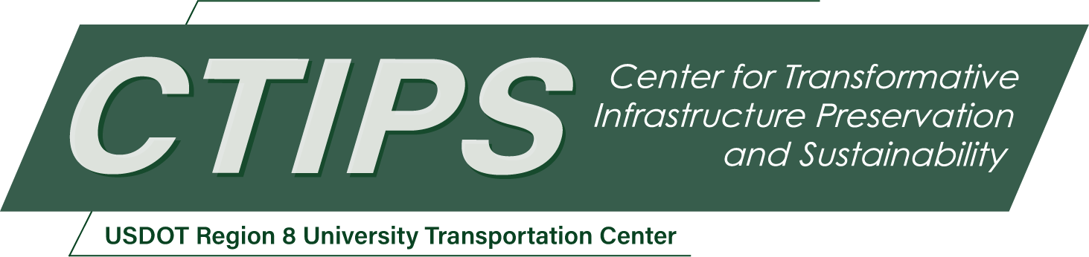

# Optimizing Guardrail Placements along Highways in Utah to Enhance Road Safety and Mitigate Road Departure Crashes

*CTIPS-008 – UTC Project Information*

|  |  |
| --- | --- |
| **Recipient/Grant Number:** | North Dakota State University, University of Utah  Grant No. 69A3552348308 |
| **Center Name:** | Center for Transformative Infrastructure Preservation and Sustainability |
| **Research Priority:** | Preserving the Existing Transportation System |
| **Principal Investigator(s):** | Nikola Marković, Ph.D.  Abbas Rashidi, Ph.D. |
| **Project Partners:** | USDOT, Office of the Assistant Secretary for Research and Technology – $50,000  Utah Department of Transportation – $52,000 |
| **Total Project Cost:** | $102,000 |
| **Project Start and End Date:** | 5/6/2024 to 5/5/2026 |

## Project Description

This project focuses on optimizing guardrail placements along highways in Utah to enhance road safety and mitigate road departure (RD) crashes. Utilizing advanced computer vision technologies and Mixed Integer Programming (MIP) models, the research aims to analyze roadside features and crash data to strategically position guardrails. By integrating detailed roadside feature data with historical crash severity information, the project seeks to identify high-risk areas for targeted guardrail installation. This approach promises to not only improve safety outcomes by reducing the frequency and severity of RD crashes but also to ensure cost-effective resource allocation, ultimately contributing to safer highways and preserving public welfare in Utah.

## USDOT Priorities

Nearly 40,000 lives are lost each year in the United States to traffic accidents, a significant portion of which, approximately 12,000 fatalities, are the result of road departure crashes—situations where vehicles leave their designated lanes and interact with dangerous roadside features. Understanding the specifics of these roadside features is vital for implementing effective safety measures against road departure incidents. In this context, the strategic placement of guardrails emerges as a pivotal action to reduce fatalities.

The UDOT plays a critical role in this scenario, as it is responsible for the judicious allocation of funds to ensure that investments are directed towards areas with the most significant potential for enhancing safety. To this end, the recommendation and prioritization of guardrail placement projects must be carefully evaluated within the confines of allocated budgets, with the aim of maximizing safety benefits and reducing road departure crashes and their severities.

The methodology proposed herein introduces a cost-effective strategy for identifying high-risk locations and prioritizing guardrail installation projects. This system is designed to maximize safety outcomes by targeting interventions at the most critical points, thereby ensuring efficient use of safety improvement project budgets. By leveraging data-driven analyses and prioritization techniques, this approach not only promises to significantly mitigate the risk of road departure crashes but also ensures that financial resources are utilized in the most impactful manner, aligning with the dual goals of enhancing public safety and maintaining economic efficiency.

## Outputs

The technology transfer process for this project will take place through three major channels: 1) publishing (presenting) research results in scholarly journals (peer-reviewed journal articles or conference papers); 2) direct interactions with UDOT personnel through training sessions and workshops the potential end-users for the results of this study.

## Outcomes/Impacts

The project aims to deliver three main outcomes: First, a computer vision model trained on Pathways images to identify roadside features like clear zones, obstacles, slopes, and guardrails. Second, a database with details on these features for five major Utah roads: SR6, SR10, SR12, SR40, and SR150. Third, we'll develop an optimization model MIP to figure out the best places to install guardrails.

It's also important to note that UDOT staff, who will benefit from this project, will discuss and assess the project's results.

## Final Report

Upon completion, the final report link will be added to the [project page on the CTIPS website](https://www.ctips.org/projects/details.php?id=606).