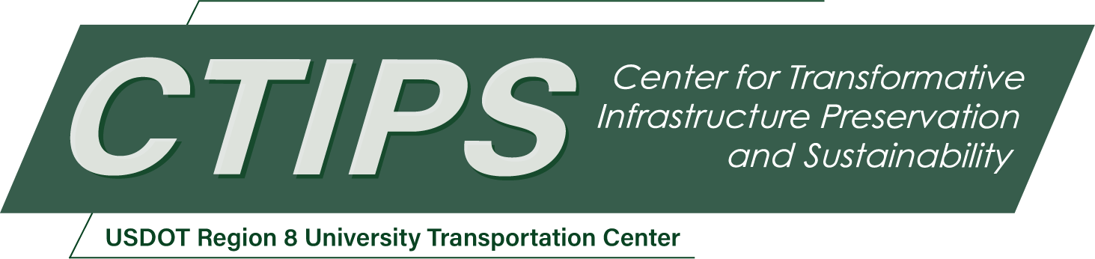

# Application of Multispectral Sensing for Detection of Corrosion in Steel Infrastructure

*CTIPS-011 – UTC Project Information*

|  |  |
| --- | --- |
| **Recipient/Grant Number:** | North Dakota State University, University of North Dakota  Grant No. 69A3552348308 |
| **Center Name:** | Center for Transformative Infrastructure Preservation and Sustainability |
| **Research Priority:** | Preserving the Existing Transportation System |
| **Principal Investigator(s):** | Sattar Dorafshan, Ph.D.  Yun Ji, Ph.D. |
| **Project Partners:** | USDOT, Office of the Assistant Secretary for Research and Technology – $98,757  University of North Dakota – $98,757 |
| **Total Project Cost:** | $197,514 |
| **Project Start and End Date:** | 6/7/2024 to 6/6/2026 |

## Project Description

A novel new sensing technology is developed in this proposal to detect uneven corrosion through light reflectance analysis. The goal of the project is to augment current corrosion detection practice using UAS. Objectives include determining reflectance properties of uneven corrosion, extracting highly associated reflectance features with corrosion, and comparing conventional visual imagery with the proposed technology in corrosion detection.

## USDOT Priorities

This proposal’s goal aligns with the US DOT’s strategic goals for safety and environmental sustainability. The investigation will result in a better understanding of steel corrosion, which could be further developed to assess different types of corrosion with different severities. Additionally, this proposal’s objectives will ensure that corrosion is identified in a timely manner since a significant amount of corrosion cannot be detected visually. The augmented defect identification model developed in this proposal could result in longer service life if relevant maintenance and repair tasks were implemented, leading to the increased service life of steel infrastructure; therefore, less steel would be required to repair and replace severely corroded steel transportation infrastructure if the technology is properly developed and implemented.

By providing better preservation, the result of this project is a contribution to less manned inspection for safer infrastructure, improved connectivity in transportation for resilient supply-chain, and introduction of autonomous systems to the future transportation system to system.

## Outputs

The findings from this proposal will be transferred to other researchers via presentations at local (UND Grad Achievement Day), regional (ND Transpiration Conference), and national (Transpiration Research Board) conferences. Additionally, the results will be transferred to professionals and practitioners via Professional development hours (PDHs) via the North Dakota ASCE and North Dakota SPE. Further technology development for commercialization will be assessed through discussion with the UND Center of Innovation.

## Outcomes/Impacts

The following outcomes are expected to be produced upon completion of this project:

* Technical knowledge about the reflectance properties of corroded steel
* Visual and spectral datasets for corroded and non-corroded steel
* Descriptive model to establish relationships between corrosion and reflectance
* Presentation and publications in scientific conferences and journals

## Final Report

Upon completion, the final report link will be added to the [project page on the CTIPS website](https://www.ctips.org/projects/details.php?id=609).