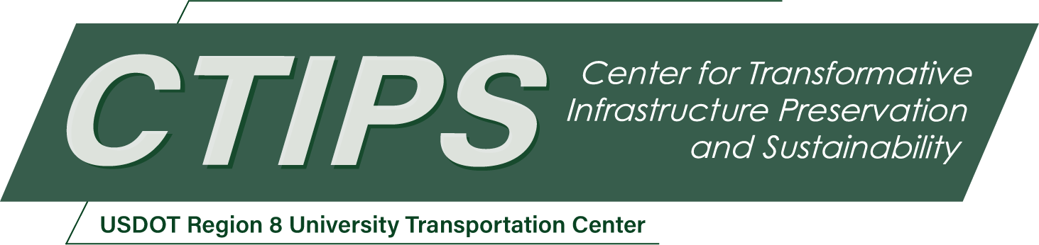

# A Machine Learning and Statistical Analysis Framework for Enhanced Engineer's Estimate Accuracy in Highway Infrastructure Projects, Phase I

*CTIPS-015 – UTC Project Information*

|  |  |
| --- | --- |
| **Recipient/Grant Number:** | North Dakota State University, University of Wyoming  Grant No. 69A3552348308 |
| **Center Name:** | Center for Transformative Infrastructure Preservation and Sustainability |
| **Research Priority:** | Preserving the Existing Transportation System |
| **Principal Investigator(s):** | Ahmed Abdelaty, Ph.D. |
| **Project Partners:** | USDOT, Office of the Assistant Secretary for Research and Technology – $51,610  Wyoming Department of Transportation – $51,610 |
| **Total Project Cost:** | $103,220 |
| **Project Start and End Date:** | 6/7/2024 to 6/6/2026 |

## Project Description

State Transportation Agencies (STAs) rely on accurate engineer's estimates for budget allocation and contractor bid evaluation in highway projects. However, recent assessments reveal significant inaccuracies, with up to 25% deviations between engineers' estimates and awarded bids in the Wyoming Department of Transportation (WYDOT) in 2019. These deviations also resonate with similar findings published by other STAs. Challenges persist due to poor data quality and variations in estimating methods. This study aims to evaluate WYDOT's engineer's estimates' accuracy against historical bid data and assess consequences on project performance. Methodologically, a literature review and questionnaire survey will inform quantitative analysis of survey data and statistical analysis of bid tabulation data. By enhancing engineer's estimate accuracy, this research seeks to minimize budget deviations, improve project performance, and promote efficiency and transparency in transportation project planning and execution.

## USDOT Priorities

The proposed research supports the USDOT strategic goal of Economic Strength and Global Competitiveness by improving the accuracy of engineer’s estimates for highway projects. The research aims to streamline project planning and execution processes. Accurate estimates ensure that resources are allocated efficiently, reducing the likelihood of budget overruns and delays. This also increases reliability and accountability regarding program budgeting. These benefits provide local economies and businesses with reliable access to transportation infrastructure, facilitating the movement of goods and services and supporting economic growth.

## Outputs

The technology transfer efforts associated with this research project encompass a multifaceted approach, including direct dissemination to agency personnel, publication in academic journals and conferences, and interactive educational webinars with local agencies. By leveraging these dissemination channels, the team seeks to maximize the impact of the research outcomes, promote widespread adoption of innovative tools and methodologies, and ultimately contribute to the advancement of the transportation infrastructure sector.

## Outcomes/Impacts

The research focuses on uncovering the prevailing methods and tools utilized by STAs for formulating engineer’s estimates, with a meticulous examination of existing models and techniques employed in accurately estimating project costs. The research also endeavors to quantify the impact of inaccurate engineer’s estimates on transportation projects by conducting rigorous statistical analyses on project performance data retrieved from WYDOT’s Construction Management Systems and bid tabulation data. These main outcomes collectively contribute to the overarching goal of the research to enhance engineer’s estimate accuracy in transportation projects and provide actionable insights and tools for WYDOT to improve their estimating practices.

## Final Report

Upon completion, the final report link will be added to the [project page on the CTIPS website](https://www.ctips.org/projects/details.php?id=613).