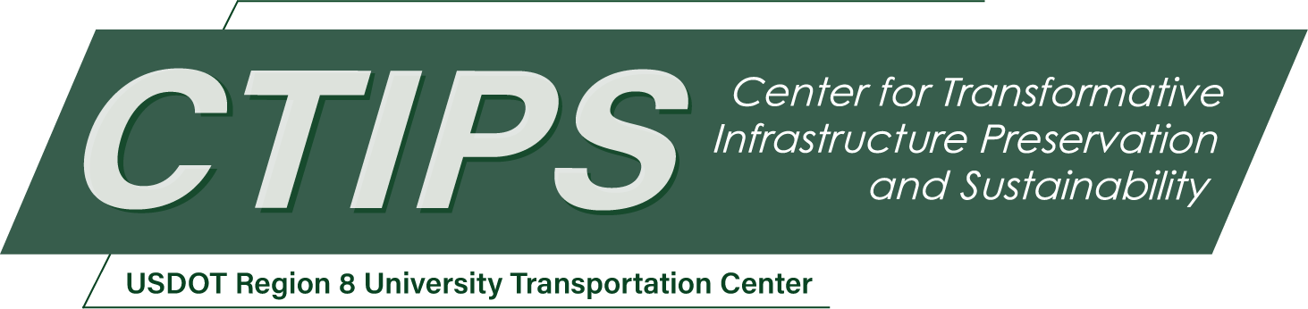

# Improving Compatibility of Truck Platooning with Existing Infrastructure via Development of Dynamic Operational Rules on Highway Networks

*CTIPS-016 – UTC Project Information*

|  |  |
| --- | --- |
| **Recipient/Grant Number:** | North Dakota State University, University of Wyoming  Grant No. 69A3552348308 |
| **Center Name:** | Center for Transformative Infrastructure Preservation and Sustainability |
| **Research Priority:** | Preserving the Existing Transportation System |
| **Principal Investigator(s):** | Yu (Fred) Song, Ph.D. |
| **Project Partners:** | USDOT, Office of the Assistant Secretary for Research and Technology – $76,685  University of Wyoming – $76,685 |
| **Total Project Cost:** | $153,370 |
| **Project Start and End Date:** | 6/7/2024 to 6/6/2026 |

## Project Description

Truck platooning presents a promising solution for reducing fuel consumption and emissions while enhancing freight transport capacity. However, the adaptivity of this technology to diverse roadway infrastructure remains a critical research need. In Wyoming, where freight transport is vital to the economy, determining how to manage truck platooning operations on existing highway networks is essential for infrastructure owner operators. This project aims to address the needs by designing and prototyping a dynamic truck platooning regulatory system. Two key algorithms will be developed: one for selecting compatible highway segments for platooning based on various roadway criteria, and another for dynamically determining operational rules for truck platoons considering real-time data such as weather and traffic conditions. These algorithms will form the basis of a comprehensive regulatory system aimed at ensuring safe and efficient truck platooning operations. Using Wyoming’s roadway, traffic, and weather data, the system will be simulated and evaluated to assess its effectiveness in achieving safety, operational, and environmental objectives. By providing insights into the compatibility of truck platooning with existing highway networks and offering a dynamic regulatory framework, this project aims to pave the way for the widespread deployment of truck platooning technology while maximizing its benefits.

## USDOT Priorities

This project will focus on adapting new transportation technologies to existing roadway infrastructure. It is closely related to the USDOT strategic goal of Transformation. On one hand, by screening existing infrastructure and assess the compatibility of new technologies to the system, we will be able to understand how much of our existing infrastructure will be able to keep bringing benefits of safe and efficient freight movement. On the other hand, throughout the research process, we will be able to identify parts of the existing infrastructure system that can be improved to better accommodate new technologies to achieve our potential goals for accessibility and mobility improvements.

## Outputs

The research team will reach out to the transportation community to discuss and present the methodologies and results of the study. Transportation practitioners and researchers are the target audience. The information dissemination will be carried out through personal communication, webpages, in-person workshops, webinars, as well as conference and journal publications and presentations. The research team will seek input from other interested parties to expand research scope and improve the study design and methodology for future projects. WYDOT has a great interest in research related to freight transportation operations and safety, therefore, personnel from WYDOT and other relevant agencies will be invited to participate in certain aspects of the project. The dynamic regulatory system with its algorithms and simulation models created in this project can be improved and expanded for development into a practice-ready system for pilot testing and deployment. The research findings will contribute to developing truck platooning related operational and design guidelines and manuals. The research team will work with WYDOT and other interested DOTs on sharing relevant findings and data, and further improving the code into a practical software application for testing and evaluating truck platooning regulatory strategies.

## Outcomes/Impacts

***A synthesis of literature on truck platooning***, including up-to-date development and deployment status, regulations, and research on truck platooning’s relationship with roadway geometry, weather, traffic, and driver behavior. Research gaps will be identified, and existing mathematical models will be used as the basis for the modeling in this project. The literature synthesis will also serve as a resource for further research in the general area of truck platooning.

***A list of data sources and variables for the modeling of truck platooning interactions and regulatory algorithm design*** will be made available. The data will be used to power up simulations in this project. The list of data sources and items will be useful for future relevant research or similar system development by other agencies.

***The dynamic regulatory system prototype, together with its mathematical models and algorithms*** for evaluating network compatibility and determining truck platooning operational rules will be the third outcome. The prototype will offer a preliminary proof of concept for a potential implementation on Wyoming roadways. The prototype’s code and simulation assessment results will be documented in detail and serve as a resource for WYDOT to assess design and management alternatives, develop truck platooning related guidelines and manuals, and conduct system expansion or incorporation into an intelligent traffic management system.

## Final Report

Upon completion, the final report link will be added to the [project page on the CTIPS website](https://www.ctips.org/projects/details.php?id=614).