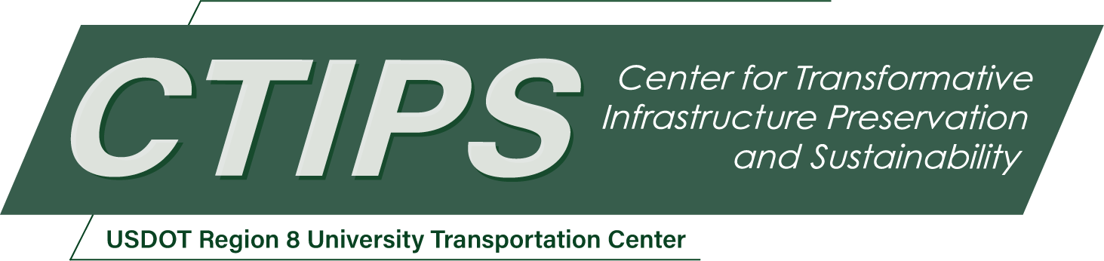

# Computer Vision Tools for Bridge Inspections and Reporting

*CTIPS-017 – UTC Project Information*

|  |  |
| --- | --- |
| **Recipient/Grant Number:** | North Dakota State University, South Dakota State University  Grant No. 69A3552348308 |
| **Center Name:** | Center for Transformative Infrastructure Preservation and Sustainability |
| **Research Priority:** | Preserving the Existing Transportation System |
| **Principal Investigator(s):** | Kwanghee Won, Ph.D.  Mostafa Tazarv, Ph.D., P.E. |
| **Project Partners:** | USDOT, Office of the Assistant Secretary for Research and Technology – $71,650  Alaska Department of Transportation & Public Facilities – $72,573 |
| **Total Project Cost:** | $144,223 |
| **Project Start and End Date:** | 6/17/2024 to 6/16/2026 |

## Project Description

Nationwide, more than 300,000 bridges are annually inspected. In many states, both a National Bridge Inventory (NBI) inspection and an element level inspection (following the AASHTO Manual for Bridge Element Inspection, MBEI) must be completed for each bridge. Using either NBI or MBEI, a significant amount of data is collected and reported. However, the data collection and reporting are usually done manually, which are time consuming, error prone, and sometimes not consistent when repeated. Computer vision can significantly expedite damage identification and quantification using images of bridge elements. The main goal of the present study is to develop practical AI tools that help inspectors with measurements and reporting of bridge defects following NBI and MBEI requirements. To achieve this goal, a few bridge elements (e.g., decks and girders) will be targeted, inspection database including photographs of the selected elements will be compiled, and computer vision tools will be developed to detect the element defects, quantify the defect per NBI/MBEI, and produce a report following standard practices. The tools, which can be standard software or web-based, will incorporate drones and mobile devices for the ease of data collection, access, sharing, and reuse in future inspections.

## USDOT Priorities

The expected outcomes of this project are directly related to the goals of “Transformation” and “Safety”. This project incorporates cutting-edge technologies such as smartphones equipped with high-resolution RGB and lidar cameras, drones equipped with combined RGB and thermal sensors, and neural networks for quick damage identification and quantification. These technologies are either new or have not been widely used in bridge engineering. Furthermore, these technologies help with quick identification and quantification of bridge damages enhancing their safety.

## Outputs

Three main deliverables of the project will be: (1) a final report, (2) a set of verified opensource computer vision codes for damage detection and quantification from images, and (3) user-friendly software for routine inspection and reporting. A project webpage is designed under the PI’s website (https://sites.google.com/view/mostafa-tazarv) in which the sponsors, personnel, and project goals are presented and the key findings are frequently updated. The final report (through the PI and CTIPS websites) and the opensource codes (through GitHub) will be publicly available at no cost for use by other researchers, DOTs, and software developers. The research findings will be further disseminated through journal publications and conference presentations. Furthermore, a presentation will be prepared for the CTIPS webinar series, which will be recorded and posted in public domains (e.g., YouTube). The research team will prepare a user guide and will organize in-person training sessions for the DOT engineers.

## Outcomes/Impacts

The main outcome of this project is a practical AI-based software package that can automatically detect bridge element (e.g., concrete deck and steel girder) damages and quantify their damage state. The impact of the work is a substantial reduction of time and cost in bridge inspection for these elements and automation in inspection data processing and reporting. The products of this project are expected to have national impacts as more than 300,000 bridges are annually inspected. Furthermore, the use of smartphones and drones allows transportation agencies to collect different information quickly and safely using cutting-edge technologies.

## Final Report

Upon completion, the final report link will be added to the [project page on the CTIPS website](https://www.ctips.org/projects/details.php?id=615).