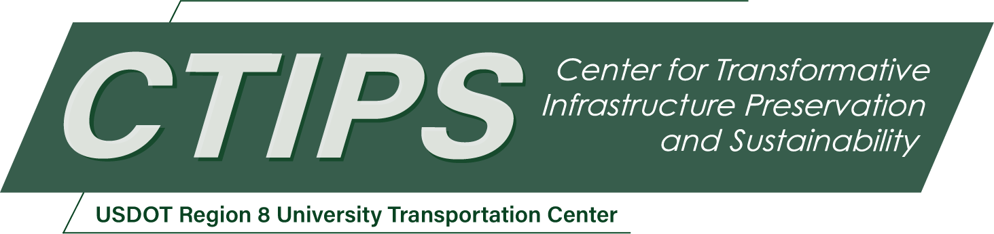

# Camera Based Computer Vision Measurements for Bridge Field Testing

*CTIPS-018 – UTC Project Information*

|  |  |
| --- | --- |
| **Recipient/Grant Number:** | North Dakota State University, South Dakota State University  Grant No. 69A3552348308 |
| **Center Name:** | Center for Transformative Infrastructure Preservation and Sustainability |
| **Research Priority:** | Preserving the Existing Transportation System |
| **Principal Investigator(s):** | Kwanghee Won, Ph.D.  Mostafa Tazarv, Ph.D., P.E. |
| **Project Partners:** | USDOT, Office of the Assistant Secretary for Research and Technology – $200,000  Alaska Department of Transportation and Public Facilities – $237,999 |
| **Total Project Cost:** | $437,999 |
| **Project Start and End Date:** | 6/17/2024 to 6/16/2026 |

## Project Description

When an inspection indicates significant damage or when higher loads are expected for a bridge, a load rating is performed, which can be done through analysis or field testing. Despite several advantages of bridge load rating using field testing data, it is not a common practice for the evaluation of bridge performance due to the cost of field operations and instrumentation. One way to reduce such costs is to utilize new technologies such as drones, computer vision, and digital image correlation (DIC). The main goal of this proposal is to develop frameworks and necessary tools to field test bridges using computer vision including either a ground-DIC system and/or drone-DIC system. Instead of using conventional sensors and data acquisition equipment, a few cameras, or a fleet of drones each equipped with a camera system will be deployed to measure bridge responses. To achieve the project goals, the most recent DIC technologies will be reviewed, current commercial and research products suitable for bridge response measurements will be evaluated, low-cost DIC tools and practical frameworks for bridge field testing will be developed, and a few bridges will be load tested using DIC and conventional sensors to validate and further refine the tools.

## USDOT Priorities

The expected outcomes of this project are directly related to the following goals: “Transformation” and “Safety”. This project incorporates cutting-edge technologies such as opensource computer vision software packages, low-cost DIC cameras, and drones to load test bridges quickly, safely, and cost effectively. The outcomes of the field testing, which includes the actual behavior of the bridge, allow a more realistic load rating and posting of bridges enhancing their overall safety.

## Outputs

The main deliverables of the project will be: (1) a final report, (2) a set of verified opensource computer vision codes and the necessary hardware for bridge field testing, (3) field-testing frameworks, and (4) user guides. A project webpage will be designed under the PI’s website (https://sites.google.com/view/mostafa-tazarv) in which the sponsors, personnel, and project goals will be presented and the key findings will be frequently updated. The final report (through the PI and CTIPS websites) and the opensource codes (through GitHub) will be publicly available at no cost for use by other researchers, DOTs, and software developers. The research findings will be further disseminated through journal publications and conference presentations. Furthermore, a presentation will be prepared for the CTIPS webinar series, which will be recorded and posted in public domains (e.g., YouTube). The research team will prepare user guides and will organize in-person training sessions for the DOT engineers.

## Outcomes/Impacts

The main outcome of this project will be a ready-to-use package including hardware and software for successful bridge field testing. Testing frameworks, user guides, and best practices will be proposed on how to use the tools for bridge load testing. The impact of the work is a substantial reduction of bridge field testing time, effort, and cost by eliminating conventional sensors and data acquisition system (DAQ). Since actual conditions and behavior of bridges are captured in these experiments, the load rating thus posting will be more realistic and reliable.

## Final Report

Upon completion, the final report link will be added to the [project page on the CTIPS website](https://www.ctips.org/projects/details.php?id=616).