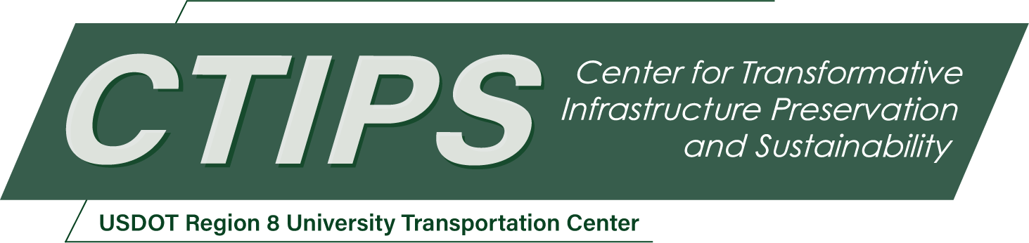

# A Framework to Reveal Gaps in Transportation Asset Maintenance Through 311 Complaints

*CTIPS-026 – UTC Project Information*

|  |  |
| --- | --- |
| **Recipient/Grant Number:** | North Dakota State University, University of Colorado Denver  Grant No. 69A3552348308 |
| **Center Name:** | Center for Transformative Infrastructure Preservation and Sustainability |
| **Research Priority:** | Preserving the Existing Transportation System |
| **Principal Investigator(s):** | Manish Shirgaokar, PhD, AICP  Aditi Misra, PhD  Wesley Marshall, PhD, PE |
| **Project Partners:** | USDOT, Office of the Assistant Secretary for Research and Technology – $60,000  University of Colorado Denver – $60,000 |
| **Total Project Cost:** | $120,000 |
| **Project Start and End Date:** | 8/17/2024 to 8/16/2026 |

## Project Description

Several mechanisms exist for identifying sites for upgrading transportation infrastructure for non-emergency maintenance. One key element is the complaints that citizens make about broken or missing features using the 311-service call system. Researchers argue, however, that some locations with less influence, either due to depressed incomes/economy or higher percentages of racial/ethnic minority households, may have fewer complaints, resulting in less actions for maintenance. Over time such locations may end up having worse infrastructure, simply because not enough complaints are being generated in disenfranchised places.

This project will rely on 311 data (2019-2023) available from open data catalogs across case cities in the U.S. We will focus on transportation-sector grievances and generate a new understanding of how citizen complaints cluster across census block group typologies. We will assemble 311 data, where available, for case cities roughly the size of Denver, CO. We will use U.S. Census data to identify types of block groups through cluster analysis and use causal spatial statistical models. The key output from this work is to generate an equity-focused gaps framework by relying on 311 calls, and share this learning with public-sector stakeholders.

## USDOT Priorities

This research is closely linked to the equity focus of USDOT’s strategic goals. By creating a replicable data-driven framework to help cities identify gaps in how 311 service calls may result in locations that are underserved by maintenance investments, this project connects to expanding access and wealth creation in disenfranchised geographies. This project will create a scalable and replicable framework that can be adopted both at various scales, local, regional, or broader. The work leverages data for informed decision-making about maintenance planning in the transportation sector.

## Outputs

The project results will be shared with stakeholders in a hybrid seminar/webinar format. Local and regional agency practitioners, who have advised the research team on several grants, will be invited to the seminar. Further, peer-reviewed conference papers and journal articles will be written to help with sharing the lessons learned. Finally, a public-facing report will be written for a practitioner audience so that the work is readily available for transportation professionals wanting to identify gaps in 311 service calls and their potential for infrastructure maintenance.

## Outcomes/Impacts

The anticipated outcomes of this research include:

* Develop of a standardized approach for transportation-sector analysis of 311 service call data
* Reveal a standard method to investigate commonalities and differences in 311 service call data across case cities
* Create a framework for identifying equity impacts from the over/under use of 311 calls across locations
* Support the goal of preserving existing transportation infrastructure by preparing cities to leverage 311 service calls to identify gaps in maintenance regimes

## Final Report

Upon completion, the final report link will be added to the [project page on the CTIPS website](https://www.ctips.org/projects/details.php?id=624).