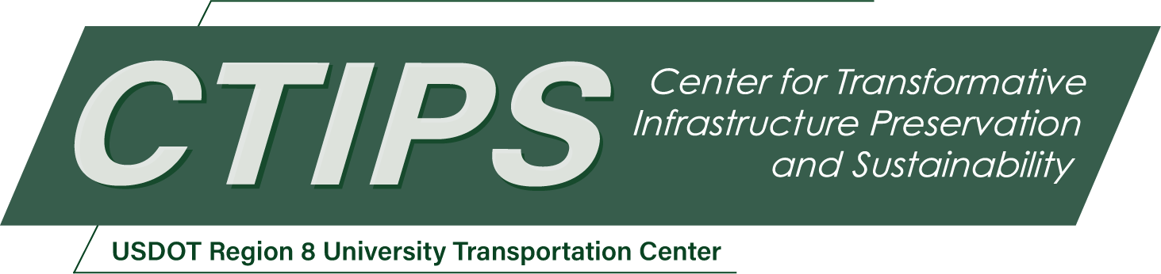

# Maintenance Optimization System to Maximize Performance of Bridges within Available Budget

*CTIPS-029 – UTC Project Information*

|  |  |
| --- | --- |
| **Recipient/Grant Number:** | North Dakota State University, University of Colorado Denver  Grant No. 69A3552348308 |
| **Center Name:** | Center for Transformative Infrastructure Preservation and Sustainability |
| **Research Priority:** | Preserving the Existing Transportation System |
| **Principal Investigator(s):** | Moatassem Abdallah, Ph.D. |
| **Project Partners:** | USDOT, Office of the Assistant Secretary for Research and Technology – $60,000  University of Colorado Denver – $60,000 |
| **Total Project Cost:** | $120,000 |
| **Project Start and End Date:** | 8/17/2024 to 8/16/2026 |

## Project Description

This research focuses on developing an advanced Maintenance Optimization System to enhance the operational efficiency of bridges within available budget. The research is vital due to the poor performance of bridges, as reflected in infrastructure reports by the American Society of Civil Engineers and aims to address the delays and inadequacies in current bridge maintenance strategies through a data-driven approach. The proposed system will leverage machine learning (ML) to predict the conditions and maintenance costs of bridge components, forming the basis for a novel optimization model that schedules maintenance tasks effectively. This dual approach ensures that limited resources are utilized in the most impactful way, extending the lifespan of bridge infrastructure while adhering to budget limitations. Outcomes include the creation of ML models capable of forecasting bridge conditions accurately and an optimization model that strategically schedules maintenance. These tools are expected to transform maintenance planning from a reactive to a proactive process, enhancing safety and extending the operational life of bridges.

## USDOT Priorities

This project directly aligns with the Transformation goal of transportation by designing forward-thinking, innovative solutions that address current challenges while paving the way for a future-ready transportation system. By developing advanced machine learning and optimization models, the project aims to modernize bridge maintenance management, a critical component of infrastructure. These models anticipate future maintenance needs and optimize interventions, ensuring that resources are allocated for maximum benefit. This proactive approach to maintenance not only enhances the current state of bridge infrastructure but also ensures that it remains robust and serviceable for future generations. The introduction of predictive tools and strategic planning methodologies is a purpose-driven innovation designed to adapt to and meet the evolving demands of a dynamic transportation landscape, ensuring it serves everyone effectively both today and in the future.

Furthermore, this research contributes to enhancing the safety of the transportation system. The accurate predictions of maintenance needs and optimizing the scheduling of maintenance interventions will improve performance of bridges and can indirectly reduce transportation-related injuries and fatalities. Bridges are vital components of the transportation network, and their failure can lead to catastrophic consequences. Through improved maintenance planning, this project ensures that bridges remain in the best performance condition based on available budgets, thus preventing accidents, and enhancing the safety of all users. This approach not only mitigates the immediate risks associated with poorly maintained infrastructure but also fosters a culture of safety that is essential for a future with reduced transportation-related injuries and fatalities.

## Outputs

A comprehensive peer-reviewed journal article will be prepared, detailing the methodologies, findings, and implications of the research. This article will target a high-impact journal within the fields of civil engineering and transportation infrastructure. The research team will also develop a conference paper to be presented at a professional conference such as TRB. This presentation will provide an opportunity to discuss the research findings with peers, receive feedback, and engage with other professionals who can directly apply these insights into practice. The final report will integrate all aspects of the research development, including literature review, development of machine learning models and optimization model, research outcomes, and recommendations for future research.

## Outcomes/Impacts

The expected outcomes of this research are expected to advance both the theoretical and practical aspects of infrastructure management. Expected outcomes include the development of machine learning models capable of accurately forecasting conditions and maintenance costs for various bridge elements, which could revolutionize current maintenance planning processes. These models will provide a predictive tool that bridges the gap between reactive and proactive maintenance strategies, allowing for more efficient budget utilization and improved bridge safety. The optimization model developed will offer a systematic approach to schedule maintenance interventions effectively, minimizing costs while maximizing bridge performance and longevity. These advancements in modeling, practices, and procedures could set new standards for bridge maintenance management, potentially influencing future research to explore similar methodologies in other areas of infrastructure. The implications for future research are vast, as this project will generate a suite of new data and methodologies that could be applied to broader contexts, encouraging a shift towards more data-driven, predictive maintenance strategies across various sectors of infrastructure systems. Furthermore, the findings of this research work will be disseminated in leading journals and professional conferences in the field. In addition to the project report and research articles, this project will produce a tangible product designed to extend its impact. A prototype software tool will be developed, integrating the machine learning and optimization models into an application that can be utilized by bridge maintenance practitioners. This tool will help in identifying maintenance needs and scheduling interventions, thereby directly enhancing the decision-making process in real-world scenarios.

## Final Report

Upon completion, the final report link will be added to the [project page on the CTIPS website](https://www.ctips.org/projects/details.php?id=627).