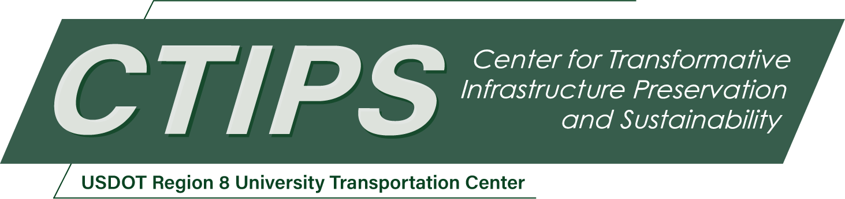

# Investigating Bond and Flexural Performance of Thin Bonded Engineered Cementitious Composite Overlay for Concrete Bridge Decks

*CTIPS-031 – UTC Project Information*

|  |  |
| --- | --- |
| **Recipient/Grant Number:** | North Dakota State University, Utah State University  Grant No. 69A3552348308 |
| **Center Name:** | Center for Transformative Infrastructure Preservation and Sustainability |
| **Research Priority:** | Preserving the Existing Transportation System |
| **Principal Investigator(s):** | Srishti Banerji, Ph.D. |
| **Project Partners:** | USDOT, Office of the Assistant Secretary for Research and Technology – $94,226.66  Utah LTAP – $94,227.00 |
| **Total Project Cost:** | $188,453.66 |
| **Project Start and End Date:** | 9/15/2024 to 9/14/2026 |

## Project Description

Resilient and durable overlays are critical for enhancing the service life of bridge decks by shielding them against harmful effects of water, chemicals, and abrasion. Currently, polymer concrete overlays are widely employed for bridge decks. Polymer concrete overlays outperform conventional concrete topping overlays. However, instances of polymer concrete overlay debonding have been encountered. Moreover, polymer concrete overlays utilize proprietary materials and are costly in price. A new class of material, Engineered Cementitious Composite (ECC) is emerging as a promising bridge-deck overlay material owing to its ultra ductile tensile crack-resistance, lower elastic modulus, and high durability characteristics. ECC overlays can provide a lightweight, cost-effective, and sustainable solution for rehabilitating and protecting bridge decks. The overarching goal of this study is to develop a comprehensive understanding on the behavior of ECC as an overlay material. The primary objectives of the study are to develop and characterize non-proprietary ECC mixture suitable for overlay applications, evaluate and compare the strength, shrinkage, and bond characteristics of ECC with other polymer and cementitious (UHPC) overlays, and to assess the flexural performance of overlay-substrate system by testing representative slabs with ECC, polymer, and UHPC overlay materials.

## USDOT Priorities

This project directly relates to the USDOT strategic goal of Economic Strength and Global Competitiveness. ECC exhibits high ductility and crack resistance which can lead to longer-lasting bridge decks, reducing the need for frequent repairs and lowering material consumption and associated costs. ECC overlays can be applied in thinner layers than traditional concrete, decreasing raw material use. The non-proprietary ECC overlay developed in this project can offer a cost-effective alternative to high-cost proprietary overlay materials while maintaining equivalent performance.

## Outputs

The expected output from this project will be in the form of test data from the comprehensive experimentation on different overlay materials, including ECC, UHPC, and PPC (polyester polymer concrete) for improving service life of bridge decks.

The results of this research will be disseminated in the following ways: 1) research results will be presented at local, national and/or international conferences and events such as the annual Utah Department of Transportation Engineering Conference, Annual Transportation Research Board Meeting, American Concrete Institute Intermountain Chapter events, and American Concrete Institute conventions; 2) the final report will be sent to structures and transportation colleagues at state and local transportation agencies; 3) at least two manuscripts will be prepared and submitted for publication in journals related to highway infrastructure and construction materials; and 4) summary slides of research results will be shared for dissemination through the CTIPS website.

## Outcomes/Impacts

The outcome of this project will result in a non-proprietary ECC mixture design that can be utilized as overlays for bridge decks. The research results will also provide valuable insights into the behavior and performance of ECC, helping to inform its potential applications in transportation infrastructure. The high durability and crack-control characteristics of ECC can enhance the long-term performance and service life of bridge deck overlays. This will reduce the need for frequent maintenance and repairs, and thus, result in significant cost savings. By extending the functioning lifespan of bridge decks and minimizing resource consumption over time, ECC also contributes to sustainable infrastructure development. Utilization of a non-proprietary overlay material can lead to self-reliance and cost-effectiveness in projects.

## Final Report

Upon completion, the final report link will be added to the [project page on the CTIPS website](https://www.ctips.org/projects/details.php?id=629).