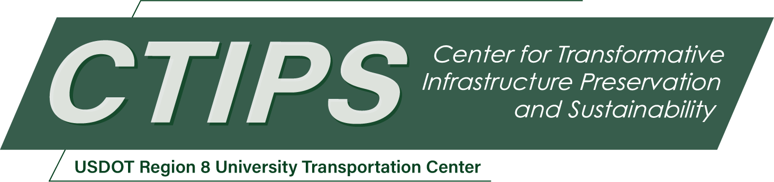

# Developing Context-Aware Computer Vision Models for Robust Data-Informed Condition Assessment of Bridges

*CTIPS-032 – UTC Project Information*

|  |  |
| --- | --- |
| **Recipient/Grant Number:** | North Dakota State University, Utah State University  Grant No. 69A3552348308 |
| **Center Name:** | Center for Transformative Infrastructure Preservation and Sustainability |
| **Research Priority:** | Preserving the Existing Transportation System |
| **Principal Investigator(s):** | Mohsen Zaker Esteghamati, Ph.D. |
| **Project Partners:** | USDOT, Office of the Assistant Secretary for Research and Technology – $98,041.61  Utah State University – $98,042.00 |
| **Total Project Cost:** | $196,083.61 |
| **Project Start and End Date:** | 9/15/2024 to 9/14/2026 |

## Project Description

Visual inspection at regular intervals has traditionally been the primary method for assessing the condition of transportation assets to ensure they meet performance objectives. However, this method is labor-intensive, costly, poses safety risks to inspectors, and may suffer from quality inconsistencies. These challenges have driven the adoption of new inspection technologies such as drone imagery and LiDAR. However, the abundance of data generated from these technologies motivates the development of automatable and reliable methodologies for data processing to understand asset conditions and performance. Computer vision (CV) techniques offer an efficient means to process visual data and extract a high-level understanding of images and videos. However, the current CV-based techniques ignore the "context" of collected data, limiting their applicability and generalizability. This study aims to develop robust, context-aware CV models with low inference times that provide actionable insights on asset conditions. The proposed models will be applied to steel bridges, and the impact of various spatial and temporal contexts on CV model performance will be examined. The project outcome will advance the state of the art of using CV models for bridge inspection and provide opportunities for integrating these technologies into integrated asset management systems.

## USDOT Priorities

This project aims to develop technology-based solutions to improve inspection quality through automation. As such, this project supports two USDOT strategic goals as follows:

1. **Transformation (Primary goal):** The project develops transformative CV technologies that substantially advance the current state of automated inspections of transportation assets to extract better engineering-oriented inferences. Such a purpose-driven innovation will modernize current inspection methods and better meet future challenges.
2. **Safety (Secondary goal):** The developed technology aids with improved and automated understanding of bridge performance issues that could pose safety risks to asset users, allowing for better maintenance and repair strategies that subsequently make these assets safer for all people.

## Outputs

The results of this research will develop an improved inspection technology, which will be published as one peer-reviewed research publication and conference presentation. All project data and models will also be published in open repositories (including USU digital commons) to allow other researchers, professionals, and practitioners to leverage the developed technology. The PI will seek opportunities to discuss the project outcome with UDOT (particularly the maintenance group) to seek opportunities for improving the current practices/methods on inspection methods that are not “boots on the ground”.

## Outcomes/Impacts

This research develops an innovative CV-based framework that emulates human perception by understanding context in visual data, and providing actionable insights for decision-making. The proposed framework will provide real-time, context-sensitive information regarding the structural integrity and operability of bridges, suitable for risk-informed maintenance strategies. In the short term, the project will advance the current state of automated inspection frameworks, ensuring accuracy and scalability. In the long term, such frameworks can be integrated into broader technological systems for integrated maintenance scheduling. Additionally, all the developed data and models will be made public, which can be used by other researchers and DOT personnel across Region 8.

## Final Report

Upon completion, the final report link will be added to the [project page on the CTIPS website](https://www.ctips.org/projects/details.php?id=630).