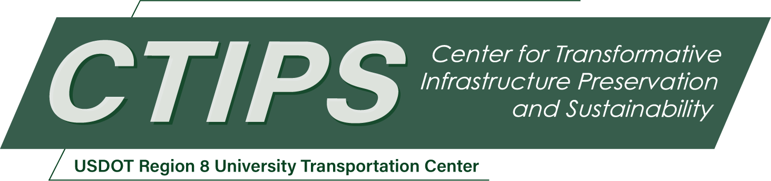

# Driving Futures: Empowering Tribal Communities through CDL Training Hub and Infrastructure Sustainability

*CTIPS-038 – UTC Project Information*

|  |  |
| --- | --- |
| **Recipient/Grant Number:** | North Dakota State University, United Tribes Technical College  Grant No. 69A3552348308 |
| **Center Name:** | Center for Transformative Infrastructure Preservation and Sustainability |
| **Research Priority:** | Preserving the Existing Transportation System |
| **Principal Investigator(s):** | Matthew Mastel  Shelby Martell |
| **Project Partners:** | USDOT, Office of the Assistant Secretary for Research and Technology – $100,000  United Tribes Technical College – $105,542 |
| **Total Project Cost:** | $205,542 |
| **Project Start and End Date:** | 10/17/2024 to 10/16/2026 |

## Project Description

This project outlines the benefits of establishing a testing hub for certifications such as Commercial Driver’s Licenses (CDL) and Heavy Equipment Operator (HEO) certifications. The creation of a centralized testing hub will increase convenience and efficiency for candidates by streamlining administrative processes, providing standardized evaluations, and ensuring quality assurance and integrity in assessments. This hub will serve as a focal point for educational resources and training opportunities for both CDL and HEO candidates.

By facilitating collaboration among tribal schools, workforce development organizations, and other stakeholders, the testing hub will contribute to economic growth while improving safety standards within the transportation and heavy equipment industries. The project aims to establish a testing hub at United Tribes Technical College (UTTC) to benefit students and professionals from tribal schools across North Dakota.

The project will impact various sectors, including transportation education, workforce development, and safety standards, ultimately leading to a more efficient and effective workforce. This testing hub will support both CDL and HEO certification processes, creating a centralized and standardized approach that benefits candidates, local industries, and the region as a whole.

## USDOT Priorities

This project aligns with the USDOT strategic goal of Economic Strength and Global Competitiveness by enhancing workforce development in both the transportation and heavy equipment operation sectors. It also promotes equity by providing Tribal communities with opportunities for high-quality education and employment in these critical industries, helping to address workforce shortages.

## Outputs

United Tribes Technical College (UTTC) will collaborate with other Tribal schools across North Dakota to develop a uniform curriculum for both Commercial Driving and Heavy Equipment Operations. UTTC will also establish itself as a central testing facility, allowing students to take their CDL and HEO tests locally, which reduces wait times for certification. This will expedite workforce entry and address the shortage of truck drivers and heavy equipment operators. In addition, UTTC will support professional development for instructors by facilitating meetings with industry leaders to ensure the training meets industry standards and supports student success.

## Outcomes/Impacts

The project will result in the development of strengthened educational and workforce programs for both CDL and HEO certification. This will provide students with valuable skills and professional growth opportunities. Long-term impacts include improved infrastructure sustainability and greater community engagement, particularly in addressing the regional workforce shortages in transportation and heavy equipment sectors.

## Final Report

Upon completion, the final report link will be added to the [project page on the CTIPS website](https://www.ctips.org/projects/details.php?id=636).