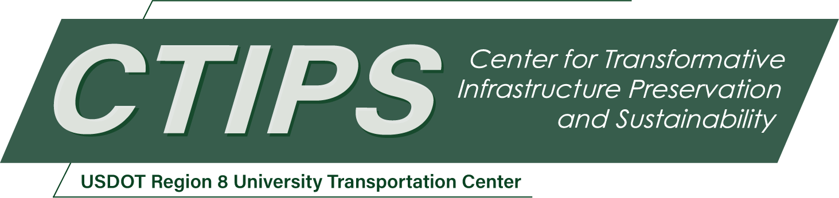

# Exploring Post-Crash Care with EMS Response to Impaired Driving Crashes in North Dakota

*CTIPS-044 – UTC Project Information*

|  |  |
| --- | --- |
| **Recipient/Grant Number:** | North Dakota State University  Grant No. 69A3552348308 |
| **Center Name:** | Center for Transformative Infrastructure Preservation and Sustainability |
| **Research Priority:** | Preserving the Existing Transportation System |
| **Principal Investigator(s):** | Ihsan Khan, Ph.D.  Kimberly Vachal, Ph.D. |
| **Project Partners:** | USDOT, Office of the Assistant Secretary for Research and Technology – $56,720  North Dakota LTAP – $20,000  Transportation Learning Network – $26,720  North Dakota DOT – $10,000 |
| **Total Project Cost:** | $113,440 |
| **Project Start and End Date:** | 4/28/2025 to 4/27/2027 |

## Project Description

Alcohol- and drug-impaired driving leads to severe crashes in North Dakota, yet police crash reports lack critical EMS response and patient care data. This study leverages NEMSIS data to assess EMS response times, treatment quality, and patient outcomes for impaired driving crashes. Using statistical analysis, time-series trends, and spatial mapping, the research identifies delays, care disparities, and high-risk locations. Findings will inform EMS resource allocation and improve post-crash care strategies, aligning with USDOT’s safety goals through advanced analytics that will transform foundational knowledge in this space.

## USDOT Priorities

This research aligns with the following USDOT Strategic Goals:

* Safety: Improving EMS response and post-crash care for impaired driving crashes will enhance patient outcomes and reduce fatalities.
* Transformation: Leveraging NEMSIS data to explore post-crash care represents an innovative approach to improving EMS systems and crash response.

## Outputs

Share findings with state agencies and other stakeholders to inform policy and investment decisions related to impaired driving and post-crash medical response.

## Outcomes/Impacts

***EMS Response Insights:***

A clear picture of how quickly and effectively EMS responds to impaired driving crashes, highlighting areas for improvement.

***Post-Crash Care Quality:***

An understanding of the care provided by EMS, including how patients are assessed, treated, and transported, for those suspected of impairment.

***Patient Outcomes:***

Insights into what factors, like timely EMS response or transport to the right facility, influence whether patients recover or face worse outcomes.

***Temporal and Spatial Insights:***

Identification of when and where impaired driving crashes are most likely to happen, helping to focus EMS resources and prevention efforts.

## Final Report

Upon completion, the final report link will be added to the [project page on the CTIPS website](https://www.ctips.org/projects/details.php?id=642).