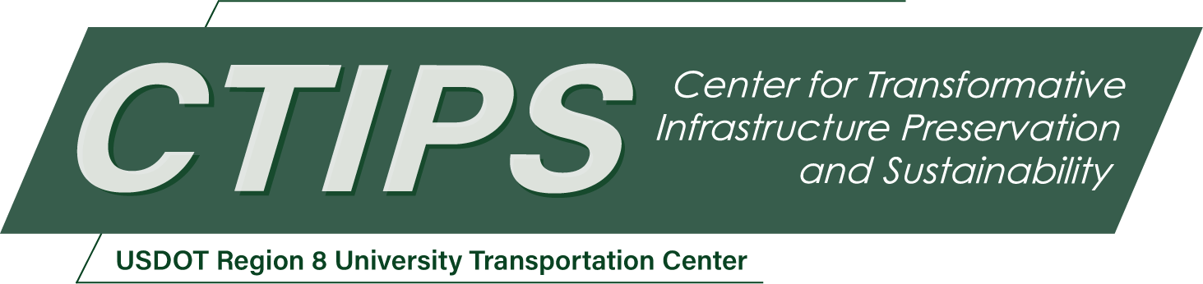

# The Downstream Infrastructure Impacts of Design Vehicle Selection

*CTIPS-047 – UTC Project Information*

|  |  |
| --- | --- |
| **Recipient/Grant Number:** | North Dakota State University, University of Colorado Denver  Grant No. 69A3552348308 |
| **Center Name:** | Center for Transformative Infrastructure Preservation and Sustainability |
| **Research Priority:** | Preserving the Existing Transportation System |
| **Principal Investigator(s):** | Wesley Marshall, PhD, PE  Aditi Misra, PhD |
| **Project Partners:** | USDOT, Office of the Assistant Secretary for Research and Technology – $80,470  University of Colorado Denver – $80,470 |
| **Total Project Cost:** | $160,940 |
| **Project Start and End Date:** | 5/21/2025 to 5/20/2027 |

## Project Description

Selecting a single design vehicle can significantly influence roadway geometry, safety, and user experience. Many roadway designs default to the largest vehicle, under the assumption that this approach will inherently accommodate smaller vehicles and non-motorized users. Yet, larger design vehicles may encourage overbuilt infrastructure, leading to wide lanes, large turning radii, and lengthy pedestrian crossings—conditions that can raise vehicle speeds and reduce pedestrian safety. Conversely, opting for a vehicle that is too small can force larger vehicles to encroach upon adjacent lanes or curbs, increasing maintenance costs and crash risks.

This project investigates how design vehicle choices affect roadway outcomes through two main phases. First, it reviews historical, current, and international practices via archival research, engineering manuals, policy documents, and interviews with practitioners. Second, it uses scenario modeling to measure how different vehicle assumptions alter intersection geometry, pedestrian crossings, and operational performance, as well as to evaluate the resulting safety and cost implications. The research will generate evidence-based guidelines for selecting an appropriate design vehicle, thereby optimizing roadway dimensions while safeguarding multimodal users.

By clarifying the downstream impacts of over- or under-designing for specific vehicles, this study aims to improve safety and functionality, minimize unnecessary infrastructure expenses, and align with broader sustainability and equity goals.

## USDOT Priorities

Preserving the existing transportation system involves ensuring that infrastructure can be maintained efficiently over the long haul. Over-designing roadways to accommodate the largest possible vehicles can lead to unnecessarily wide roads, increased maintenance costs, and potentially unsafe conditions. By contrast, implementing a more context-sensitive design vehicle selection approach can help:

* Extend Infrastructure Lifespan: Designing to the actual needs of the majority of users can reduce wear and tear on infrastructure.
* Optimize Maintenance Investments: Right-sizing facilities to local context allows agencies to allocate limited resources more effectively.
* Improve Safety and Access: Balancing design vehicle considerations can result in improved safety and promote a more efficient multimodal network.
* Enhance Resiliency: Avoiding overbuilt infrastructure helps decrease material use and maintenance demands, aligning with long-term system preservation objectives.

In this way, the research supports the USDOT’s goal of preserving and enhancing the existing system by providing new insights for roadway design.

## Outputs

The project will produce several tangible deliverables to facilitate widespread dissemination and application of findings:

* Technical Report: A final report detailing the research process, findings, and recommended design vehicle selection framework for practitioners.
* Conference Presentations and Journal Articles: Presentations at national conferences such as TRB (Transportation Research Board) as well as submission of journal manuscripts to peer-reviewed transportation journals.
* Webinars: Targeted training sessions for transportation agencies and consultants to share best practices.
* Open-Source Scenario Templates: Templates for roadway design and turning radius analyses that agencies can adapt for local contexts.

## Outcomes/Impacts

The expected outcomes and impacts of this research include:

1. Refined Infrastructure Design Standards: The research will produce more nuanced guidelines that help agencies tailor infrastructure dimensions-particularly pavement sections and intersection geometry-to actual vehicle usage patterns.
2. Reduced Maintenance Burden: By avoiding unnecessary under- or overdesign, roadways can require fewer midlife rehabilitations, resulting in lower overall maintenance expenses and freeing up funds for other critical system preservation needs.
3. Enhanced Safety: Right-sizing designs can reduce speeds on overly wide roads and shorten crossing distances, improving conditions while still accommodating commercial vehicles.
4. Long-Term Asset Management Benefits: Integrating a more precise design vehicle choice into asset management strategies allows transportation agencies to invest in infrastructure that delivers the highest return on investment over its life cycle.
5. Policy and Practice Advancements: The results will inform updates to design manuals, municipal standards, and training protocols, influencing both immediate and long-range planning efforts.

## Final Report

Upon completion, the final report link will be added to the [project page on the CTIPS website](https://www.ctips.org/projects/details.php?id=645).