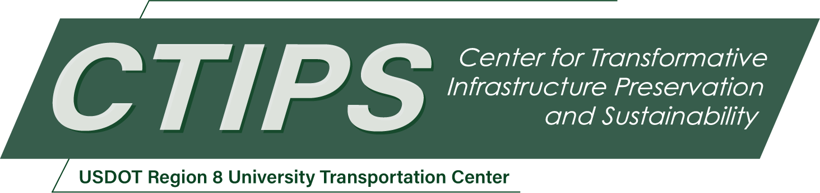

# Transformative and Innovative Work in Transportation

*CTIPS-049 – UTC Project Information*

|  |  |
| --- | --- |
| **Recipient/Grant Number:** | North Dakota State University, University of Denver  Grant No. 69A3552348308 |
| **Center Name:** | Center for Transformative Infrastructure Preservation and Sustainability |
| **Research Priority:** | Preserving the Existing Transportation System |
| **Principal Investigator(s):** | Patrick Sherry, PhD |
| **Project Partners:** | USDOT, Office of the Assistant Secretary for Research and Technology – $40,000  Truckload Carrier Association – $20,000  University of Denver – $20,000 |
| **Total Project Cost:** | $80,000 |
| **Project Start and End Date:** | 6/19/2025 to 6/18/2027 |

## Project Description

The proposed project is designed to increase participants’ likelihood of accepting a position in the transportation industry with the potential for developing innovative and transformative approaches and solutions to transportation challenges and opportunities. To achieve this goal a one-day workshop attended by undergraduates and prospective students interested in learning more about the transportation industry will be conducted. The workshop will consist of invited addresses by transportation professionals, university faculty and others who have a deep knowledge and understanding of the transportation industry. The participants will also be asked to complete a series of vocational interest inventories designed to assist in matching interest’s preferences and values with the opportunities, task, mission, and activities of transportation companies and agencies. Interactive exercises, group discission, and short videos will be utilized to convey information and increase awareness of opportunities in the industry.

## USDOT Priorities

The proposed workshop addresses USDOT strategic goals related to Economic Strength and Global Competitiveness, as well as Transformation.

In terms of economic strength, the workshop will attempt to develop strong interest in the transportation sector by educating students as to what career paths are available and encouraging their choice in that career. In addition, it will also explore strategies to develop a skilled workforce capable of leading future innovations in transportation infrastructure, design, and systems management. Speakers will share case studies, insights, and recommendations to stimulate a deeper understanding of how a strong workforce that not only meets today’s transportation challenges but is poised to lead in an increasingly complex and technology-driven future.

In support of the USDOT goal of transformation, which supports a design for the future, the proposed workshop represents an investment in attracting and retaining highly skilled and talented college graduates who will engage in innovative research to meet the upcoming challenges and modernization needs of the transportation system of the future. The recruitment of highly qualified college graduates will contribute to the ongoing development of breakthrough and transformative technology which will serve the transportation industry and sector.

The workshop will address the identification and establishment of a good fit with and the congruence between personal styles, values and occupational interests with the characteristic activities, goals, rewards and incentives associated with the transportation sector. Identifying and understanding the components of this congruence will likely lead to greater job satisfaction. Longevity and success in the industry. Research has found that the higher degree of congruence between personal and occupational interests, values and associated activities is also associated with higher degrees of career and occupational success.

## Outputs

The results of the work performed will most likely lead to an increase in the number of college graduates that apply for and accept a position in the transportation sector. The outcome of more applicants and acceptances into positions will likely be a greater number of skilled professionals.

## Outcomes/Impacts

The expected outcome of the workshop will be an increase in the number of students interested in transportation careers will likely be that they will continue to devise and develop innovative and transformative solutions to the congestion challenges faction the transportation sector.

Ultimately the outcome will be to continue to sustain and enhance economic growth, to complete globally and to also improve efficiency, safety, and/or cost effectiveness of the transportation system through the development and commercialization of new technologies and practices. This will be achieved by having highly skilled and competent college graduates entering transportation careers and positions.

## Final Report

Upon completion, the final report link will be added to the [project page on the CTIPS website](https://www.ctips.org/projects/details.php?id=647).