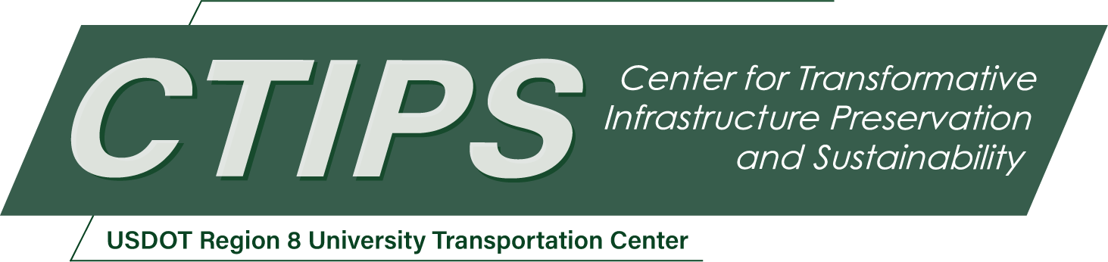

# Agentic Artificial Intelligence Framework for Enabling Automation in Bridge Inventory Database Using Large Language Models

*CTIPS-050 – UTC Project Information*

|  |  |
| --- | --- |
| **Recipient/Grant Number:** | North Dakota State University, Colorado State University  Grant No. 69A3552348308 |
| **Center Name:** | Center for Transformative Infrastructure Preservation and Sustainability |
| **Research Priority:** | Preserving the Existing Transportation System |
| **Principal Investigator(s):** | Gaofeng Jia, Ph.D. |
| **Project Partners:** | USDOT, Office of the Assistant Secretary for Research and Technology – $80,000  Colorado State University – $80,000 |
| **Total Project Cost:** | $160,000 |
| **Project Start and End Date:** | 6/19/2025 to 6/18/2027 |

## Project Description

An ideal bridge inventory database is a structured, accessible repository of comprehensive information about bridges, such as their condition, inspection history, load capacities, design types, age, and other relevant attributes. Such database is essential to support data-informed and cost-effective bridge asset management and preservation. However, current practices for retrieving information/insights from and updating the databases lack automation, are slow and extremely expert-demanding. The increasing amount and the heterogeneous (multi-modal) nature of the data make it increasingly challenging to manually synthesize and distill useful insights from and/or updating the databases, calling for smart analytics technologies to automate the management, extraction, and interpretation of bridge inventory data. While large language models (LLMs) have shown the capability of comprehending multi-modal data, they remain significantly underutilized in bridge management. This project will investigate the viability of using LLMs to build artificial intelligence (AI) agents that can extract, memorize bridge condition from inspection records/reports, and enable standardized interpretation and organization of insights to support bridge preservation. The AI agents will convert raw and semi-structured bridge inventory data (e.g., inspection narratives, images, sensor signals) into structured database entries, summaries, and actionable recommendations. Users can interact intuitively with the AI agents via natural language queries, enabling efficient retrieval and interpretation of critical insights for bridge management. The agentic AI framework can achieve specified goals with minimal human/expert intervention.

## USDOT Priorities

This project directly supports the USDOT strategic goal of Transformation by developing an agentic AI framework to automate the interpretation, organization, and retrieval of bridge inventory data, which advances bridge management by moving beyond conventional systems toward intelligent agents capable of reasoning over multi-modal inputs and interacting with users through natural language. By enhancing the efficiency, accuracy, and scalability of bridge preservation workflows, the project also contributes to Economic Strength and Global Competitiveness, enabling more cost-effective bridge management. Overall, this project is transformative in applying emerging AI capabilities to a traditionally manual, expert-driven domain and positions the U.S. at the forefront of AI-enabled civil engineering innovation.

## Outputs

The developed agentic AI tools will be presented to CDOT Bridge and Structure Asset management team to support the adoption of intelligent automation in bridge inventory data management. These tools will help CDOT reduce manual data processing burdens, improve the consistency of condition interpretation, and enable more efficient, informed decision-making. The research findings will also be disseminated through technical publications in academic journals, along with presentations at academic and practitioner-focused events as well as CTIPS events. Recorded webinars and tutorials will be created, stored, and made publicly accessible to ensure broad accessibility and practical knowledge transfer to a range of stakeholders. In addition, the project will release benchmarking datasets tailored to AI agents for enabling automation in bridge inventory database. This resource will enable researchers and practitioners to evaluate and compare AI agents in extracting, summarizing, and reasoning over multi-modal inspection data, supporting future innovation in intelligent bridge management systems.

## Outcomes/Impacts

This project will produce several high-impact research and technological outcomes that contribute to advancing AI-driven bridge preservation and support more intelligent, scalable, and cost-effective infrastructure management:

1. An agentic AI framework for bridge inventory management that enables automated interpretation and retrieval of condition-related information, reducing manual processing burdens and improving the consistency and timeliness of database updates.
2. A set of deployable AI agents tailored for bridge inventory data workflows, offering practical tools for tasks, such as extracting insights from inspection narratives and recommending maintenance actions, empowering transportation agencies to make faster, data-driven decisions.
3. A benchmarking dataset of annotated multi-modal bridge inventory data that will serve as a foundational resource for evaluating future agentic AI systems, supporting reproducibility and accelerating innovation across the AI-agent-driven bridge preservation research community.
4. Prototype software tools and configuration guidelines that demonstrate how AI agents can be embedded into existing bridge management pipelines, showcasing measurable improvements in data quality, operational efficiency, and long-term maintenance planning.
5. A comprehensive final report detailing procedures, system design, implementation steps, evaluation results, and practical recommendations for technology adoption, along with supporting materials to guide state DOTs and transportation agencies in scaling the approach. Also, one or more journal papers will be published.

## Final Report

Upon completion, the final report link will be added to the [project page on the CTIPS website](https://www.ctips.org/projects/details.php?id=648).