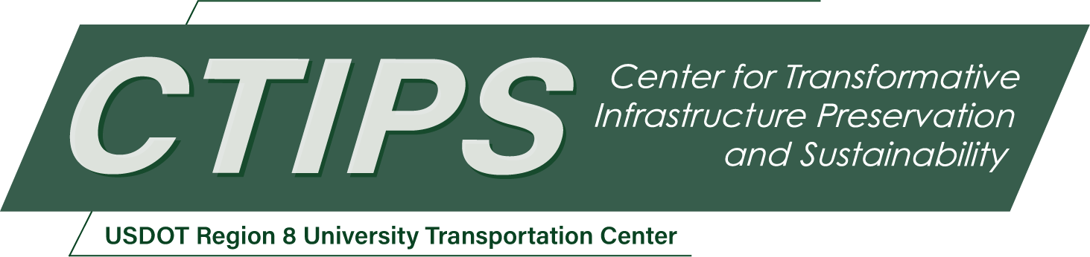

# An End-to-End Deep Learning System for Pavement Distress Detection, Severity Estimation, and Condition Reporting

*CTIPS-051 – UTC Project Information*

|  |  |
| --- | --- |
| **Recipient/Grant Number:** | North Dakota State University  Grant No. 69A3552348308 |
| **Center Name:** | Center for Transformative Infrastructure Preservation and Sustainability |
| **Research Priority:** | Preserving the Existing Transportation System |
| **Principal Investigator(s):** | Armstrong Aboah, Ph.D.  Denver Tolliver, Ph.D. |
| **Project Partners:** | USDOT, Office of the Assistant Secretary for Research and Technology – $40,000  North Dakota State University – $40,000 |
| **Total Project Cost:** | $80,000 |
| **Project Start and End Date:** | 7/18/2025 to 7/17/2027 |

## Project Description

Pavement condition assessment is essential for roadway asset management, yet current methods are fragmented, manual, and resource-intensive. Traditional workflows require separate tools for distress detection, severity and depth estimation, and overall condition classification, leading to inefficiencies. While deep learning models have emerged for tasks like crack segmentation or pavement condition index (PCI) prediction, most remain task-specific and lack integration. This project proposes a unified, end-to-end multitask framework using multimodal data for automated pavement assessment. By fusing high-resolution RGB images with stereo-derived depth maps, the system jointly performs distress detection, severity estimation, depth prediction, and condition classification. It also includes a natural language processing (NLP) module to generate human-readable reports tailored to agency workflows. The architecture features a shared encoder with four task-specific decoders, leveraging cross-task correlations to enhance generalization and reduce the need for separate models. Training will use a regional dataset annotated for all four outputs, with performance evaluated using intersection-over-union (IoU), mean absolute error (MAE), and F1-score. Report quality will be assessed using text similarity metrics and expert feedback. The central hypothesis is that multitask learning with multimodal inputs will improve accuracy and efficiency while reducing manual labor. This builds on the PI’s prior work in multitask PCI estimation, multimodal segmentation, and explainable reporting for infrastructure.

## USDOT Priorities

This project directly supports the USDOT’s Safety goal by automating the detection, severity estimation, and classification of pavement distresses, enabling timely maintenance and reducing crash risks. It enhances field response through interpretable depth estimates and automated reporting. Additionally, it advances the Transformation goal by integrating multitask learning, multimodal data fusion, and natural language generation into a unified and scalable pavement assessment system. Methodologically and operationally, the work transitions from fragmented tasks to a real-time, intelligent framework that enhances decision-making and ensures the accessibility of outputs to non-technical stakeholders, reinforcing USDOT’s priorities for safety and innovation.

## Outputs

The proposed research will produce several impactful outputs that support both academic advancement and practical implementation in transportation infrastructure management. These outputs are designed to ensure accessibility, reproducibility, and broad dissemination to agencies, researchers, and practitioners.

To maximize dissemination and impact, a structured technology transfer plan will be implemented, including:

* Peer-reviewed dissemination: Publish in leading journals and submit to at least one national conference (e.g., TRB or IEEE ITSC).
* Web-based dissemination: Share models, demos, and reports on a project webpage linked to the PI’s lab and CTIPS site; promote via webinars and social media.
* Agency outreach: Present findings to local and regional DOTs, including North Dakota DOT, and explore pilot integration opportunities.
* Virtual and in-person engagement: Participate in CTIPS-led webinars, Transportation Learning Network (TLN) sessions, and practitioner workshops; produce short instructional videos.
* Workshops and conferences: Contribute to national workshops on AI-driven asset monitoring to share outcomes and support implementation.

## Outcomes/Impacts

This research will deliver a fully functional multitask pavement assessment system that automates distress detection, severity and depth estimation, condition classification, and natural language reporting. It replaces fragmented, manual evaluations with a faster, consistent, and data-driven approach.

Key outputs include an open-source software prototype with core deep learning models, preprocessing tools, and reporting capabilities, adaptable for agency use and mobile platforms.

The system improves safety, reliability, and maintenance efficiency by enabling early detection and better prioritization. Automated reporting ensures accessibility for both field engineers and decision-makers, enhancing workflows and planning.

The project is expected to influence inspection protocols, procurement, and training, while also providing a scalable framework applicable to other infrastructure types. It contributes both immediate tools and long-term value toward safer, cost-effective, and AI-integrated transportation systems.

## Final Report

Upon completion, the final report link will be added to the [project page on the CTIPS website](https://www.ctips.org/projects/details.php?id=649).