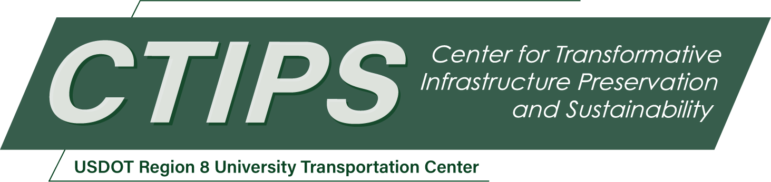

Quantitative Assessment of Anti-Icing Efficacy on Highway Surfaces Using Light Reflectance
CTIPS-053 – UTC Project Information
Recipient/Grant Number: | North Dakota State University, University of North Dakota (UND)  Grant No. 69A3552348308
Center Name: | Center for Transformative Infrastructure Preservation and Sustainability
Research Priority: | Preserving the Existing Transportation System
Principal Investigator(s): | Sattar Dorafshan, Ph.D.  Sherif Gaweesh, Ph.D., P.E.  Markus Allgaier, Ph.D.
Project Partners: | USDOT, Office of the Assistant Secretary for Research and Technology – $347,463  University of North Dakota – $111,565  Collins Engineers – $138,090  Keyence – $17,808  DTN – $80,0000
Total Project Cost: | $694,926
Project Start and End Date: | 10/23/2025 to 10/22/2027

Project Description
The project aims to quantify road surface condition under adverse weather in North Dakota. First, the current winter maintenance and winter road condition monitoring practices across North Dakota will be reviewed. Historical crash data will be used to identify high-risk roadway segments encountering elevated crash frequencies and/or severities related to adverse road surface conditions. The project aims to quantify the safety performance to estimate and predict crash occurrences related to adverse weather conditions using statistical modeling techniques and network screening analysis. Once the importance of road surface condition on safety is quantify, type of surface condition (ice, snow, slush) on highways using diffuse reflectance spectroscopy (DRS) will be identified. A physical model for near-infrared reflectance of road surface will be developed to classify the surface condition in a noncontact manner. The models will be developed under controlled conditions and will be evaluated under field condition by determination of the optical properties of water, snow, and ice (and black ice). In the next objective, DRS-based discriminative to measure brine eutectic point and efficacy will be developed by generating samples with different portions of water, salt, and beet juice (primarily used in North Dakota) under different temperature. Through noncontact quantification of deicer efficacy, the project contributes to preservation of transportation infrastructure and safety. The research team will develop deterministic and data-driven models to correlate DRS features under different brine conditions with respect to eutectic points in a controlled environment, and benchmarking and compare the results of DRS brine models with observations. The final task of this objective is to develop a low-cost in-situ optical sensor framework for field deployment using diode lasers, super luminescent LEDs, hyperspectral camera, single-pixel and array photodiodes, and spectral filters. The payload SWaP (size, weight and power) analysis for potential Unmanned Aerial Systems (UAS) applications. The research team will establish an UAS operation training program for students to get UAS licensed, to shadow UAS-assisted inspections, to analyze UAS data.

USDOT Priorities
Section left blank until USDOT’s new priorities and RD&T strategic goals are available in Spring 2026.

Outputs
This research will generate actionable insights and technological advancements to enhance winter roadway safety and maintenance through real-time ice detection, brine phase, predictive modeling, and network screening analysis. The outcome of this study will be widely disseminated through prestigious peer reviewed journals and presentations on UND campus (e.g., Grad Day, Graduate Seminars, etc.), regional conferences (e.g., North Dakota Transportation Conference, and CTIPS planned conference), and national conferences (e.g., TRB and ASCE), and professional development hours (PDHs) for practicing engineers. The data generated from this investigation will be published as open access on scientific repositories such as UND commons and Elsevier Data in Brief.

Outcomes/Impacts
North Dakota is a pioneer in the development and application of UAS and autonomous systems for transportation infrastructure for monitoring and condition assessment. The use of non-contact sensing to understand the optical properties of bridges with ice formation under different modes will have a path to automation. The technical outputs of this investigation will be shared on UND Advanced Transportation Infrastructure Center. Additionally, the outputs will be shared with North Dakota DOT, upon project completion, to augment existing brine application during winter maintenance practices.
The project increases the body of knowledge in transportation safety, and winter maintenance while contributing to a broader body of science such as physics and diffuse spectroscopy. The proposed protype is expected to optimize brine application procedures while demonstrating the capability of a noncontact sensor to effectively distinguish ice on highways through advanced sensing and data analysis.
An additional desirable outcome would be to develop an industry partnership among useful and interested parties. The DOT’s winter maintenance crew would be an excellent source of information on current practices that might help to identify more opportunities for the payload. Riding along with the crews to learn how de-icing is done, and in the future, deploying the payload could provide a great opportunity to demonstrate the payload’s capabilities as well as fine tune it for even better performance. A second partnership to explore would be with technology providers, such as Resonon – a company known for its Hyperspectral Imagery (HSI) equipment or (insert lighting/laser/de-icing/etc.) for their products and knowledge in their respective fields. A third partnership avenue might be to connect with peers at other colleges also researching the icing phenomenon and pool our data and resources to generate even more robust datasets, models, and prototypes. Finally, the opportunity to generate interest in UND’s students, prospective or current, through outreach could prove helpful to the project, as well.

Final Report
Upon completion, the final report link will be added to the project page on the CTIPS website.

