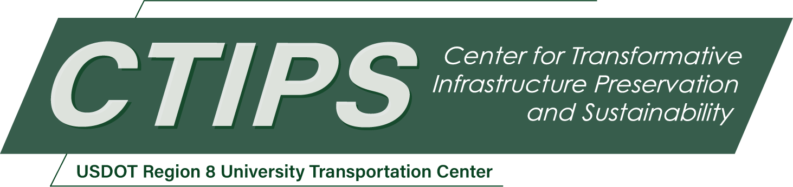

AI-Driven Infrastructure Prioritization: Vision-Language Model Framework for Capital Planning
CTIPS-054 – UTC Project Information
Recipient/Grant Number: | North Dakota State University, Colorado State University  Grant No. 69A3552348308
Center Name: | Center for Transformative Infrastructure Preservation and Sustainability
Research Priority: | Preserving the Existing Transportation System
Principal Investigator(s): | Debasish Jana, Ph.D.
Project Partners: | USDOT, Office of the Assistant Secretary for Research and Technology – $89,000  Colorado State University – $89,000
Total Project Cost: | $178,000
Project Start and End Date: | 10/28/2025 to 10/27/2027

Project Description
This project develops a scalable, AI-powered framework for automated condition assessment and capital investment prioritization of road and bridge infrastructure across Colorado. Current manual inspection methods are costly, slow, and limited in coverage, often missing early signs of degradation. Leveraging recent advances in Vision-Language Models (VLMs), the project proposes a novel approach that extracts Pavement Condition Index (PCI) and bridge deck ratings from satellite and street-level imagery using VLMs guided by prompt engineering and in-context learning, requiring no retraining, and will be validated against Colorado Department of Transportation (CDOT) inspection records using machine learning model accuracy metrics.
The framework integrates three components: (1) Infrastructure condition (2) network criticality, computed via graph-theoretic metrics and traffic data, and (3) hazard exposure, based on geospatial data for landslides, wildfires, and floods. These layers will be synthesized into a weighted prioritization model to rank road segments for capital upgrades, refined through CDOT expert review.
A web-based GIS tool will visualize prioritization results, supporting interactive exploration and decision-making. The tool will be pilot-tested with CDOT districts, and outcomes will be disseminated through a final report, peer-reviewed publication, Transportation Learning Network (TLN) webinar, and Colorado LTAP training.
By integrating AI, geospatial analytics, and network modeling, this project addresses data-driven infrastructure planning needs—enhancing efficiency, reliability, and resilience—while offering a replicable model nationwide.

USDOT Priorities
Section left blank until USDOT’s new priorities and RD&T strategic goals are available in Spring 2026.

Outputs
This project will deliver key outputs for infrastructure assessment and prioritization, including:
- A VLMs based methodology for scalable analysis of satellite and street-level imagery.
- A validated AI model for automated estimation of PCI and bridge deck ratings.
- A prioritization framework integrating condition, importance, and hazard exposure.
- A web-based GIS tool for visualization and planning support.
- A curated dataset of imagery, condition, criticality, and hazard indices for Colorado roads.
The project will also foster new collaborations with state and municipal agencies beyond CTIPS through pilot testing and stakeholder engagement.
Technology Transfer (T2) Plan: To ensure broad impact, the project will:
- Publish peer-reviewed articles on the methodology, validation, and national relevance.
- Deliver webinars through TLN and CTIPS for practitioners and researchers.
- Launch a public webpage hosting interactive GIS tool, documentation, and findings.
- Present results at professional and academic conferences.
- Partner with Colorado LTAP to share training materials for local agencies.
These efforts will support practical adoption, stimulate further research, and promote scalable use of AI-driven tools for safer, more efficient infrastructure planning.

Outcomes/Impacts
This project will deliver a transformative, AI-driven framework for infrastructure condition assessment and investment prioritization, addressing key limitations in scalability, cost, and timeliness. By operationalizing VLMs, it will generate actionable tools for informed maintenance planning and capital allocation. Key outcomes include:
- A VLM-based pipeline for automated, interpretable extraction of pavement and bridge condition data from imagery—reducing reliance on manual surveys.
- A three-dimensional prioritization model integrating condition, importance, and hazard exposure for objective, budget-conscious decision-making.
- A web-based GIS tool for scenario analysis and planning by state and local agencies.
- Improved reliability through earlier detection of deteriorating or at-risk segments, reducing lifecycle costs and enhancing hazard preparedness.
- Practical and policy-relevant outputs that can guide agency practices, modernize inspection protocols, and establish a precedent for AI integration in asset management.
These results will offer immediate operational value in Colorado and serve as a scalable model for nationwide adoption.

Final Report
Upon completion, the final report link will be added to the project page on the CTIPS website.

