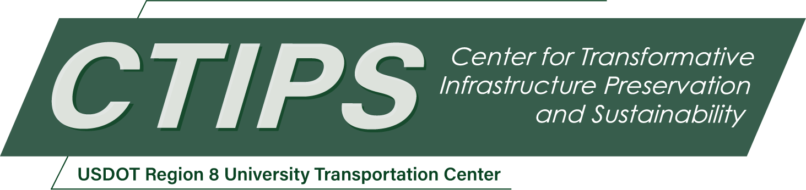

Stick & Scan: Perching Uncrewed Aerial System for Efficient In-Situ Non-Destructive Inspection of Transportation Infrastructure
CTIPS-055 – UTC Project Information
Recipient/Grant Number: | North Dakota State University, Colorado State University (CSU)  Grant No. 69A3552348308
Center Name: | Center for Transformative Infrastructure Preservation and Sustainability
Research Priority: | Preserving the Existing Transportation System
Principal Investigator(s): | Yanlin Guo, Ph.D.  Jianguo Zhao, Ph.D.  Rebecca Atadero, Ph.D., P.E.
Project Partners: | USDOT, Office of the Assistant Secretary for Research and Technology – $89,000  Colorado State University – $89,000
Total Project Cost: | $178,000
Project Start and End Date: | 10/28/2025 to 10/27/2027

Project Description
This project aims to develop and demonstrate a perching-capable Uncrewed Aerial System (UAS) for efficient, in-situ non-destructive evaluation (NDE) of transportation infrastructure, particularly in difficult-to-access locations such as the undersides of bridges. While UAS platforms are widely used for visual inspection, their application for contact-based NDE is rather limited due to challenges in stability, power consumption, and force control during flight. To address these challenges, the proposed UAS integrates a thermoplastic-based perching mechanism and a planar sensor positioning system, enabling stable attachment to structural surfaces and precise scanning using contact sensors. The research has two primary objectives: (1) to design and build a perching UAS platform, and (2) to demonstrate its feasibility for deploying contact-based NDE technologies in both lab and field settings. An external advisory board will guide feasibility testing and support technology transfer. This project addresses USDOT goals related to infrastructure safety and resilience and is expected to advance automated inspection methods while reducing risks to human inspectors. Outcomes will be disseminated through workshops, webinars, and conference presentations targeting practitioners and industry stakeholders.

USDOT Priorities
Section left blank until USDOT’s new priorities and RD&T strategic goals are available in Spring 2026.

Outputs
An external advisory board (EAB) consisting of two to three members, such as NDE practitioners and transportation asset managers, will be established. The EAB will provide feedback to help align the project with practical needs throughout the technology development process, thereby maximizing its potential for successful technology transfer to practice. EAB will also review research outcomes and reports. The research outcome will be disseminated to practitioners via webinar(s) hosted by CTIPS. We will also post videos for the UAS NDE platform on YouTube Channels as well as social media (e.g., LinkedIn, X, etc.). The research outcomes will be presented at regional and national transportation conferences attended by practitioners, such as the Western Bridge Preservation Partnership Forum and/or the TRB Annual Meeting. The research team will engage practitioners through workshop(s) that showcase the developed technologies and explore commercialization pathways. The workshop(s) will feature physical demonstrations of the developed new technology (at CSU or in the field), technical presentations, and practitioner discussions. EAB members will also be invited to participate in the workshop(s).

Outcomes/Impacts
The expected outcomes from this project will include:
- A prototype UAS platform capable of perching on the side or underside of structures, integrating both mechanical and electrical components.
- A planar positioning system that will be integrated with the UAS to perform scans of a designated area.
- Control algorithms that enable the UAS to perch at designated locations and perform NDE scanning on structures.
- A comprehensive report documenting the design process and evaluating the feasibility of the UAS platform for NDE applications in transportation infrastructure.
- An evaluation report synthesizing feedback from EAB members, identifying practical value and potential implementation fields for the developed technology.
The project is expected to transform current practices in NDE and structural inspection through the introduction of autonomous, perching-capable UAS technology. The specific impacts include:
- Expand the reach of NDE to previously inaccessible locations, supporting earlier and more complete identification of structural defects and enhancing overall structural safety.
- Eliminate risks to human inspectors by using UAS to replace snooper trucks or rope climbing-based inspection.

Final Report
Upon completion, the final report link will be added to the project page on the CTIPS website.

