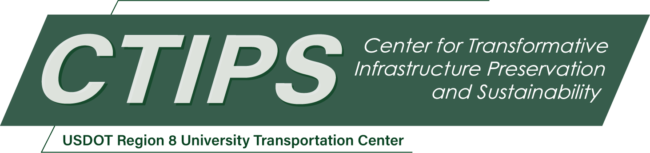

Rural Multi-Hazard Infrastructure Planning for Evacuation Safety and Economic Resilience
CTIPS-057 – UTC Project Information
Recipient/Grant Number: | North Dakota State University, Utah State University  Grant No. 69A3552348308
Center Name: | Center for Transformative Infrastructure Preservation and Sustainability
Research Priority: | Preserving the Existing Transportation System
Principal Investigator(s): | Sarah A. Grajdura, Ph.D.
Project Partners: | USDOT, Office of the Assistant Secretary for Research and Technology – $105,000  Utah Local Technical Assistance Program – $105,000
Total Project Cost: | $210,000
Project Start and End Date: | 11/17/2025 to 11/16/2027

Project Description
Wildfires increasingly threaten communities in the wildland-urban interface (WUI), where development meets flammable vegetation. As the WUI expands, disaster risk grows more complex—wildfires often trigger or are intensified by other hazards, including earthquakes and severe weather. These compounding risks are particularly challenging in rural areas, where infrastructure is limited, evacuation routes are sparse, and small businesses play a central role in community resilience.
This project addresses two key gaps: (1) rural wildfire evacuation under multi-hazard conditions and (2) business continuity for small enterprises in WUI regions. First, a Community Advisory Board (CAB) will guide the research, ensuring it reflects local knowledge and priorities. Second, we will develop a GeoAI-driven, agent-based model to simulate evacuations under wildfire, earthquake, and weather scenarios, using environmental, transportation, and demographic data. Third, we will build a business continuity model that predicts how rural businesses recover from wildfire disruptions, incorporating infrastructure damage, supply chain challenges, and community displacement.
Findings will inform land use planning, evacuation design, and recovery strategies tailored to rural needs. This work supports future disaster response and strengthens long-term resilience for communities facing growing multi-hazard risks.

USDOT Priorities
Section left blank until USDOT’s new priorities and RD&T strategic goals are available in Spring 2026.

Outputs
The results of this research project will be shared with researchers, professionals, community members, and practitioners through multiple channels. The researchers will maintain relationships with the community advisory board, routinely sharing findings and updates. We will share a policy brief aimed at community members, along with the final report.
Additional findings will be presented at local, national, and international conferences, including events hosted by the Transportation Research Board, Utah Department of Transportation, Utah Division of Emergency Management, Institute of Transportation Engineers, Natural Hazards Center, and the Association of Collegiate Schools of Planning. Alongside the final project report, we plan to prepare and submit three manuscripts for publication in journals focused on transportation and emergency planning. The final report will also be distributed to transportation personnel at state and local agencies and made available online. Additionally, we will host a CTIPS webinar to present the key outcomes of the project and seek opportunities to share our findings via other virtual and in-person opportunities. All data will be de-identified and made publicly available through the NSF National Hazards Engineering Research Infrastructure Data (NHERI) Depot. Data analysis scripts will be shared via github.com.

Outcomes/Impacts
This research study is expected to generate innovative tools and community-informed frameworks that significantly enhance rural multi-hazard disaster preparedness and recovery planning. One of the most impactful outcomes will be the integration of community voices through the formation of a Community Advisory Board (CAB), leading to evacuation and business continuity plans that are locally grounded, culturally relevant, and practically feasible. The CAB model itself is anticipated to serve as a replicable best practice for stakeholder engagement in rural infrastructure planning, with potential to influence regional and state-level emergency preparedness guidelines.
Key technical deliverables will include two GeoAI-driven agent-based simulation models: one for rural multi-hazard evacuation and another for business continuity recovery. These models represent major advancements in rural transportation and economic resilience modeling, offering detailed scenario simulations that account for hazard-specific challenges, local infrastructure limitations, demographic factors, and behavioral responses. These tools will be accessible through the NHERI DesignSafe Data Depot, supporting broader research and planning applications across the U.S.
The practical impacts of this research are substantial. The evacuation model will enhance rural transportation system safety, helping to identify evacuation bottlenecks and optimize routing under wildfire, seismic, and extreme weather conditions. The business continuity model will support more durable and reliable recovery strategies by forecasting which businesses are most at risk and identifying infrastructure investments that can improve long-term economic resilience. These models and the accompanying policy brief are expected to inform local emergency management practices, guide infrastructure investment decisions, and potentially shape new regulatory standards for rural disaster preparedness.

Final Report
Upon completion, the final report link will be added to the project page on the CTIPS website.

