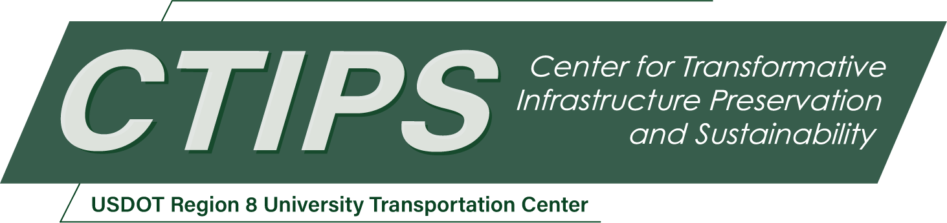

Investigation of Dual Grade/Hybrid Steel Plate Girders Utilizing Stainless Steel
CTIPS-058 – UTC Project Information
Recipient/Grant Number: | North Dakota State University, Utah State University  Grant No. 69A3552348308
Center Name: | Center for Transformative Infrastructure Preservation and Sustainability
Research Priority: | Preserving the Existing Transportation System
Principal Investigator(s): | Matthew Hebdon, Ph.D., P.E.
Project Partners: | USDOT, Office of the Assistant Secretary for Research and Technology – $78,814  Virginia Transportation Research Council – $78,814
Total Project Cost: | $157,628
Project Start and End Date: | 11/17/2025 to 11/16/2027

Project Description
Corrosion is a significant concern for steel bridges, and if not properly designed for or mitigated, can lead to costly maintenance or service failures. One option for making steel bridges more corrosion-resistant is to use 50CR steel (formerly ASTM A1010 steel), which is a stainless steel having similar mechanical properties to typical bridge steels with much greater corrosion resistance. While 50CR steel is attractive due to its corrosion resistance, it’s cost, relative to traditional carbon steel, may preclude it from use due to budgetary restraints. One option for making 50CR steel bridges more cost-effective is by using a dual-grade girder, in which 50CR is used in targeted corrosive locations, while conventional steel, such as uncoated ASTM A709 Grade 50W or coated steel, are used elsewhere. By using the more costly material where it provides the most benefit, dual-grade girders have the potential to achieve life cycle cost savings by reducing future maintenance and increasing the overall service life of the girder. There has been limited research addressing the strength and corrosion performance of 50CR welded to traditional carbon steels. This research will quantify the corrosion behavior and the galvanic corrosion potential through accelerated corrosion tests. Strength tests will also be performed to evaluate any potential issues with the welding processes required for hybrid welding.

USDOT Priorities
Section left blank until USDOT’s new priorities and RD&T strategic goals are available in Spring 2026.

Outputs
The results of this research will be incorporated into specifications governing the design and fabrication of US bridge structures. Specifically, the AASHTO LRFD Bridge Design Specification and the American Welding Society (AWS) D1.5 – Bridge Welding Specification will be updated with the results of this research. Additionally, the research results will be disseminated through refereed journal publications, technical presentations, and conferences on steel bridges and fabrication.

Outcomes/Impacts
Since dual grade connections using 50CR are a novel strategy for mitigating corrosion for bridges, existing research on this topic is limited. Bridge owners and designers currently have few opportunities to incorporate 50CR into designs due to limited specifications on the topic. The proposed research will produce recommended design, welding, inspection, and installation specifications that will provide a methodology for welded and bolted dual-grade connections made with 50CR to be used in targeted locations where the use of 50CR is most justified. This guidance will provide a valuable resource to DOTs and bridge engineers who wish to use 50CR in cost-effective designs, continuing a nationwide focus on the consideration of life cycle cost, rather than only initial cost.

Final Report
Upon completion, the final report link will be added to the project page on the CTIPS website.

