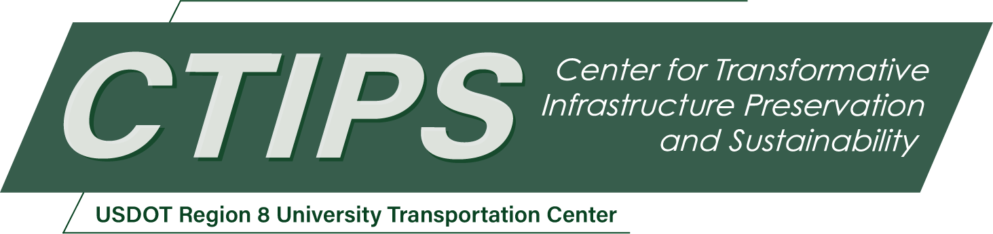

Seismic Performance of Steel-Concrete Composite Bridge Piers
CTIPS-059 – UTC Project Information
Recipient/Grant Number: | North Dakota State University, Utah State University  Grant No. 69A3552348308
Center Name: | Center for Transformative Infrastructure Preservation and Sustainability
Research Priority: | Preserving the Existing Transportation System
Principal Investigator(s): | Soheil Shafaei, Ph.D.
Project Partners: | USDOT, Office of the Assistant Secretary for Research and Technology – $105,019.33  Utah Local Technical Assistance Program – $105,000.00
Total Project Cost: | $210,019.33
Project Start and End Date: | 11/17/2025 to 11/16/2027

Project Description
Traditional cast-in-place reinforced concrete (RC) bridge piers, while common, involve a slow, multi-stage construction process that elevates project costs and poses significant safety risks to both workers and traffic within construction zones. As an innovative alternative, steel-concrete composite structural systems offer a substantial reduction in construction time—estimated at up to 40%—thereby enhancing project schedules and safety. However, the widespread adoption of this promising technology is currently hindered by a critical lack of knowledge and codified guidance regarding its seismic design and performance.
This research proposal aims to systematically address this gap by investigating the key parameters influencing seismic behavior and developing comprehensive design guidelines for steel-concrete composite bridge piers. The project’s primary objectives include the design of multiple composite pier configurations, the development and validation of detailed 3D nonlinear finite element models using commercial software, and the execution of performance-based seismic assessments to evaluate damage states and failure mechanisms. The methodology will encompass designing piers and their connections to foundations based on existing experimental data, creating sophisticated finite element models that capture material nonlinearities, and conducting extensive pushover analyses under varied conditions (e.g., axial load, reinforcement ratio, cross-sections).
The anticipated outcomes are highly relevant to national strategic goals, including improved seismic resiliency through higher ductility and stiffness, enhanced safety via reduced time in construction work zones, and greater economic efficiency through accelerated project completion. The research will yield advanced numerical modeling techniques, performance-based seismic design methodologies, and practical design recommendations and specifications for structural engineers. These outputs will be disseminated through a final report to the US Department of Transportation (USDOT), peer-reviewed publications, and conference presentations, ultimately contributing to the development of more resilient and rapidly constructed infrastructure. The project also offers significant educational benefits by training students in advanced computational modeling and seismic design, fostering collaboration between academia and industry. The work is planned over a 24-month period, structured into four six-month phases covering literature review and design, model development, seismic analysis, and the formulation of final design guidelines.

USDOT Priorities
Section left blank until USDOT’s new priorities and RD&T strategic goals are available in Spring 2026.

Outputs
The research project creates significant outputs for the USDOT and bridge structural engineers:
- Advance numerical modeling: The final report presents a guideline for developing detailed 3D nonlinear finite element modeling of bridges with steel-concrete composite piers using a commercial finite element software program.
- Performance-based seismic design: The final report presents a guideline for conducting seismic evaluation of bridges with steel-concrete composite piers.
- Seismic design of bridges: The final report presents design recommendations and specifications for the seismic design of bridges with steel-concrete composite piers.
- Publications and presentations: the findings of this research project will be published in peer-reviewed journals and national/international conferences.

Outcomes/Impacts
The research project creates significant outcomes for the USDOT and bridge structural engineers:
- Advance numerical modeling: The advanced nonlinear finite element modeling is used to predict accurately seismic behavior of bridges with steel-concrete composite piers.
- Performance-based seismic design: The performance-based seismic design is used to design seismic resilient bridges with steel-concrete composite piers.
- Seismic design of bridges: The seismic design recommendations and specifications for bridges with steel-concrete composite piers will results in reduction of seismic vulnerability of critical infrastructure in the US.

Final Report
Upon completion, the final report link will be added to the project page on the CTIPS website.

