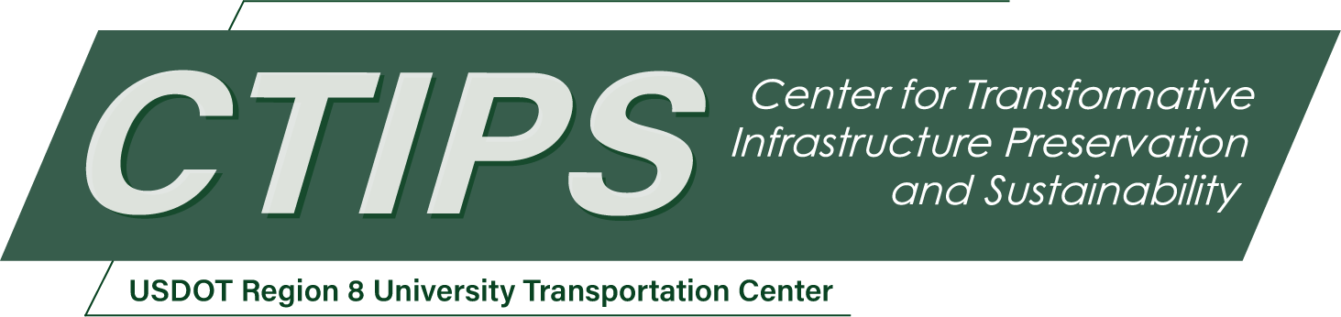

An AI-Based Reasoning Framework for Proactive Infrastructure Monitoring and Preservation Using Connected Autonomous Vehicles
CTIPS-061 – UTC Project Information
Recipient/Grant Number: | North Dakota State University, University of Utah  Grant No. 69A3552348308
Center Name: | Center for Transformative Infrastructure Preservation and Sustainability
Research Priority: | Preserving the Existing Transportation System
Principal Investigator(s): | Chenxi “Dylan” Liu, Ph.D.  Xiaoyue “Cathy” Liu, Ph.D., P.E.
Project Partners: | USDOT, Office of the Assistant Secretary for Research and Technology – $50,000  Utah Department of Transportation – $50,000
Total Project Cost: | $100,000
Project Start and End Date: | 12/13/2025 to 12/12/2027

Project Description
This research proposes the development of a CAV-based Proactive Infrastructure Preserving (CAV-PIP) system to enhance the safety, resilience, and operational efficiency of transportation infrastructure. The system leverages the sensing and communication capabilities of connected autonomous vehicles (CAVs) to enable continuous, real-time detection and reporting of roadway anomalies, such as pavement distress and damaged traffic signage. By fusing multi-modal sensor data and incorporating a retrieval-augmented generation (RAG) framework with large language models (LLMs), the system constructs a dynamic prior knowledge base to reason about infrastructure conditions and recommend context-aware maintenance actions. The project aims to transform current reactive maintenance practices into a data-driven, proactive framework that improves decision-making for transportation agencies. The system will be validated through simulation in the CARLA (Car Learning to Act) environment and supported by curated real-world datasets. Expected outcomes include an integrated detection and reasoning framework, structured maintenance reporting tools, and publicly shareable datasets and software packages. The project’s broader impact lies in advancing intelligent infrastructure monitoring technologies, reducing long-term maintenance costs, and contributing to safer and more sustainable transportation systems.

USDOT Priorities
Section left blank until USDOT’s new priorities and RD&T strategic goals are available in Spring 2026.

Outputs
The proposed research is designed with a strong emphasis on practical implementation and technology transfer. Key project outputs will include a deployable AI-powered anomaly detection algorithm, a structured reporting framework for infrastructure conditions, and a simulated prototype of the CAV-PIP system developed and validated in the CARLA environment. All software tools, annotated datasets, and model architectures will be documented and prepared for public release, enabling adoption or adaptation by State DOTs, local agencies, and industry partners. In addition, the system’s modular design will facilitate integration with existing connected vehicle platforms or maintenance management systems. Findings and tools will be disseminated through technical reports, open-source repositories, conference presentations, and targeted outreach to transportation agencies. These efforts will support Region 8’s broader goal of accelerating the deployment of intelligent infrastructure monitoring technologies and advancing data-driven maintenance strategies across the transportation ecosystem.

Outcomes/Impacts
The proposed research is expected to generate impactful outcomes across multiple dimensions of transportation infrastructure management. At the operational level, the CAV-PIP system will enable transportation agencies to detect infrastructure issues earlier and with greater spatial and temporal resolution, reducing reliance on infrequent manual inspections and improving the responsiveness of maintenance interventions. This proactive monitoring approach is anticipated to extend the service life of roadway assets, lower overall maintenance costs, and mitigate the safety risks associated with undetected pavement failures or missing signage. At the system level, the project demonstrates how advanced sensing, AI, and vehicle connectivity can be integrated into a cohesive framework that operates within existing traffic environments—showcasing a scalable model for infrastructure preservation. In the long term, the adoption of such technologies has the potential to support more sustainable asset management strategies, reduce unplanned service disruptions, and enhance overall transportation system resilience. By delivering both methodological advancements and practical insights, the project will contribute meaningfully to the modernization and long-term sustainability of infrastructure management practices in Region 8 and beyond.

Final Report
Upon completion, the final report link will be added to the project page on the CTIPS website.

