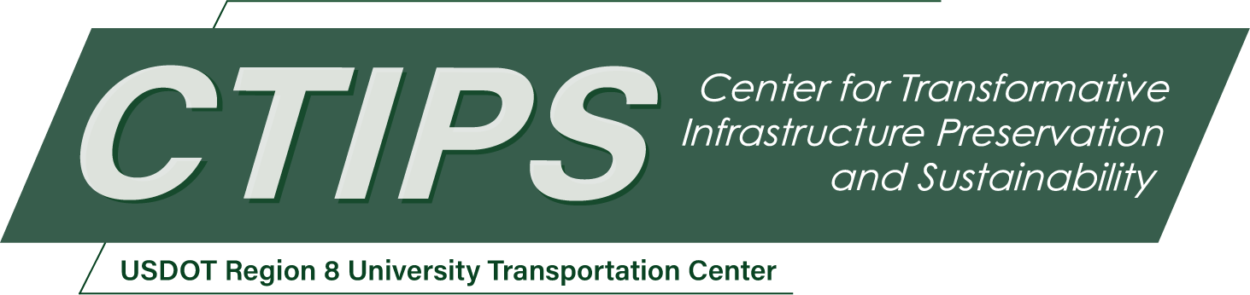

Enhancing Chain-Up Infrastructure and Compliance in Utah’s Mountain Corridors: A Data-Driven Evaluation
CTIPS-062 – UTC Project Information
Recipient/Grant Number: | North Dakota State University, University of Utah  Grant No. 69A3552348308
Center Name: | Center for Transformative Infrastructure Preservation and Sustainability
Research Priority: | Preserving the Existing Transportation System
Principal Investigator(s): | Nikola Marković, Ph.D.
Project Partners: | USDOT, Office of the Assistant Secretary for Research and Technology – $50,000  Utah Department of Transportation (UDOT) – $60,000
Total Project Cost: | $110,000
Project Start and End Date: | 12/13/2025 to 12/12/2027

Project Description
This project evaluates chain-up infrastructure and traction-device compliance in Utah’s mountain corridors, focusing on how roadway geometry, winter operations, and driver behavior affect chain-up performance during storm events. Using geospatial analysis, operational data, and field-informed insights, the study identifies locations where existing chain-up facilities may be undersized, poorly situated, or constrained by topography. The project also develops AI-generated videos that explain operational challenges, noncompliance impacts, and potential improvement strategies to both practitioners and the traveling public. Project findings will inform infrastructure upgrades, policy refinements, and improved communication practices, with methods and products readily transferable to mountain corridors in other western states.

USDOT Priorities
Section left blank until USDOT’s new priorities and RD&T strategic goals are available in Spring 2026.

Outputs
Technology transfer will occur through three coordinated channels designed to reach practitioners, agencies, and the traveling public. First, the project will produce a suite of practitioner-ready AI-generated videos that clearly explain chain-up challenges, canyon-specific operational constraints, and recommended infrastructure or policy solutions. These materials will be formatted for use in UDOT training sessions, safety briefings, public outreach efforts, and winter-preparedness campaigns.
Second, the research team will conduct targeted workshops and briefings with UDOT Region 2 staff, the Utah Highway Patrol, local canyon jurisdictions, and other winter-operations partners. These sessions will facilitate dialogue around key findings, allow agencies to review scenario visualizations, and support coordinated planning for improved chain-up management.
Third, the project will prepare concise technical summaries and communication products suitable for public-facing campaigns, including pre-winter messaging, traveler-education materials, and digital content for UDOT’s communication platforms. By combining clear visualizations with actionable recommendations, these outputs will help ensure that research findings translate directly into improved practice, enhanced traveler understanding, and safer winter operations in Utah’s canyon corridors.
- A detailed, canyon-by-canyon evaluation of chain-up infrastructure conditions, geometric constraints, and operational challenges in Parley’s Canyon, Big Cottonwood Canyon, and Little Cottonwood Canyon.
- AI-generated videos and visualization products tailored for both practitioners and the general public, clearly explaining chain-up issues, winter-operations constraints, and recommended solutions.
- A prioritized set of infrastructure, policy, and communication improvements that complement and extend the findings of UDOT’s parallel study.
- Enhanced communication tools designed to increase traction-law compliance, support winter-travel preparedness, and reduce storm-related delays and safety incidents.

Outcomes/Impacts
This project will produce a comprehensive, canyon-by-canyon evaluation of chain-up infrastructure, geometric constraints, and operational challenges that contribute to winter-weather delays and safety risks in Utah’s mountain corridors. A key outcome is a set of practitioner-ready, AI-generated videos and visualizations that clearly communicate current problems, why traction-device compliance matters, and how proposed improvements would enhance safety and mobility. These communication tools will support UDOT’s winter-operations messaging, improve public understanding of traction requirements, and strengthen compliance among passenger-vehicle drivers and heavy-vehicle operators.
The project will also generate a prioritized list of infrastructure, policy, and communication strategies that complement and extend the findings of the parallel UDOT study. By combining data-driven analysis with effective outreach media, the project will help reduce loss-of-traction events, improve snowplow performance, and minimize corridor disruptions during storms. The resulting guidance will support decision-makers, maintenance personnel, enforcement partners, and the traveling public, ultimately improving safety, reliability, and preparedness across Utah’s mountain highway system.

Final Report
Upon completion, the final report link will be added to the project page on the CTIPS website.

