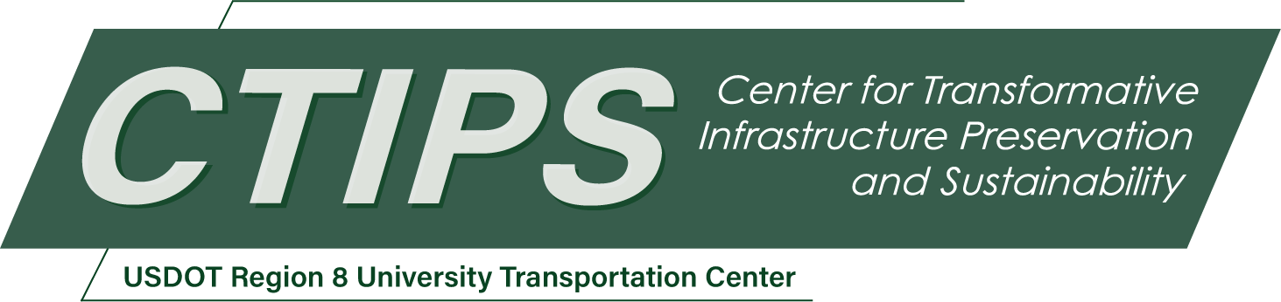

Enhancing the Wyoming Pavement Quality Rating Estimation
CTIPS-056 – UTC Project Information
Recipient/Grant Number: | North Dakota State University, University of Wyoming  Grant No. 69A3552348308
Center Name: | Center for Transformative Infrastructure Preservation and Sustainability
Research Priority: | Preserving the Existing Transportation System
Principal Investigator(s): | Shahbaz Khan, Ph.D.  Raghupathi Kandiboina, Ph.D.  Khaled Ksaibati, Ph.D., P.E.
Project Partners: | USDOT, Office of the Assistant Secretary for Research and Technology – $112,902  Wyoming Department of Transportation – $112,902
Total Project Cost: | $225,804
Project Start and End Date: | 8/19/2026 to 11/30/2029

Project Description
The Wyoming Department of Transportation (WYDOT) currently relies on the Pavement Quality Rating (PQR) as the primary performance indicator within its pavement management system. Although PQR is conceptually bounded between 0 and 5, the existing formulations occasionally produce negative values due to nonlinear distress transformations, reducing interpretability and limiting long-term forecasting reliability. This research aims to refine, calibrate, and validate an improved PQR model that addresses these deficiencies while aligning with national performance metrics. The study aims to document existing pavement performance practices from state agencies and research institutions, evaluate and modify the current PQR equations to ensure bounded and explainable outputs, incorporate a layered cracking taxonomy, quantify the influence of traffic loading and pavement structural characteristics, and validate predictive capability using historical distress datasets. Expected outcomes include a robust, bounded PQR equation, decision-support thresholds, and associated implementation tools for integration into WYDOT’s pavement management workflows. The resulting model will improve data-driven decision-making, support cost-effective rehabilitation planning, and enhance long-term asset management capability. The project will also provide educational and technology transfer benefits through student engagement, conference presentations, and peer-reviewed publications.

USDOT Priorities
Section left blank until USDOT’s new priorities and RD&T strategic goals are available in Spring 2026.

Outputs
The results and products of this project, such as a developed effective pavement performance equation and associated decision trees, will be disseminated through peer-reviewed journal articles and showcased at scientific research conferences like the annual Transportation Research Board (TRB). This will help in transferring methodologies, results, and products to the national and international pertinent research communities. Workshops, seminars, and webinars will be arranged to further disseminate the research findings and communicate their outcomes with professionals, practitioners, and highway agencies such as WYDOT. The incremental results and progress of this project will be consolidated in a semi-annual progress report. Upon the completion of this project, it will be synthesized along with recommendations and guidelines in a technical report.

Outcomes/Impacts
The outcome of this research project will help to develop a pavement performance equation that will take care of the existing issues, such as negative value and cracking integration. Finally, the outcome of this research can be used by policymakers to implement the best practices of the pavement management system (PMS) in their respective regions.

Final Report
Upon completion, the final report link will be added to the project page on the CTIPS website.

