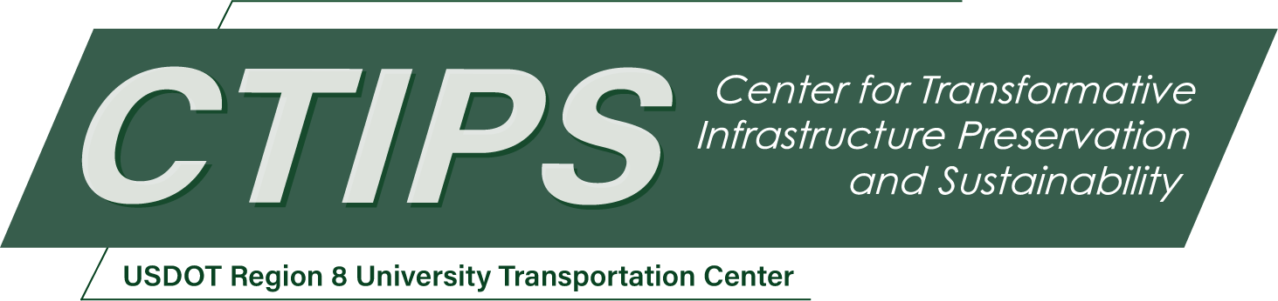

Assessing the Impacts of Safety-Focused Design Interventions on Arterial Roadways
CTIPS-067 – UTC Project Information
Recipient/Grant Number: | North Dakota State University, University of Colorado Denver  Grant No. 69A3552348308
Center Name: | Center for Transformative Infrastructure Preservation and Sustainability
Research Priority: | Preserving the Existing Transportation System
Principal Investigator(s): | Wesley Marshall, Ph.D., P.E.  Aditi Misra, Ph.D.
Project Partners: | USDOT, Office of the Assistant Secretary for Research and Technology – $131,248  University of Colorado Denver – $131,248
Total Project Cost: | $262,496
Project Start and End Date: | 1/10/2026 to 1/9/2028

Project Description
Arterial roadways serve as critical connectors in urban transportation networks, yet their design often prioritizes vehicular mobility over safety. Despite the widespread application of safety-focused infrastructure interventions on local and collector streets, similar strategies are rarely implemented on arterials due to concerns over congestion, emergency response, and operational efficiency. However, these design choices have proven to result in unsafe conditions.
This project investigates how infrastructure design interventions can improve safety on arterial roadways while addressing operational and institutional constraints. The research follows a phased approach. First, it examines the historical, regulatory, and policy factors that have limited the adoption of safety-focused interventions on arterials, including the influence of fire codes and emergency response standards. Second, it assesses the real-world impacts of infrastructure changes on speeds, crashes, and emergency response metrics. Finally, it synthesizes findings to develop actionable recommendations and a decision-making framework for arterial design.
By providing an evidence-based understanding of how design choices affect safety, mobility, and community outcomes on arterial corridors, this study aims to inform infrastructure design practices.

USDOT Priorities
Section left blank until USDOT’s new priorities and RD&T strategic goals are available in Spring 2026.

Outputs
The project will produce several tangible deliverables to facilitate widespread dissemination and application of findings:
- Technical Report: A final report detailing the research process, findings, and recommendations for practitioners.
- Conference Presentations and Journal Articles: Presentations at national conferences such as TRB (Transportation Research Board) as well as submission of journal manuscripts to peer-reviewed transportation journals.
- Webinars: Targeted training sessions for transportation agencies and consultants to share best practices.
- Case Study Database: Compilation of examples and outcomes for agency reference.

Outcomes/Impacts
The expected outcomes and impacts of this research include:
- Improved Design Practices – The research will collect, assess, and collate evidence to inform roadway design guidelines.
- Enhanced Safety – The resulting research will identify evidence-based, data-driven, safety-focused interventions that can be used on arterials, where our most dangerous crashes tend to take place, and promote better safety outcomes.
- Policy Advancements – Impacts could also include changes to municipal standards, fire codes, and agency policies. Integrating a more precise design vehicle choice into asset management strategies.

Final Report
Upon completion, the final report link will be added to the project page on the CTIPS website.

