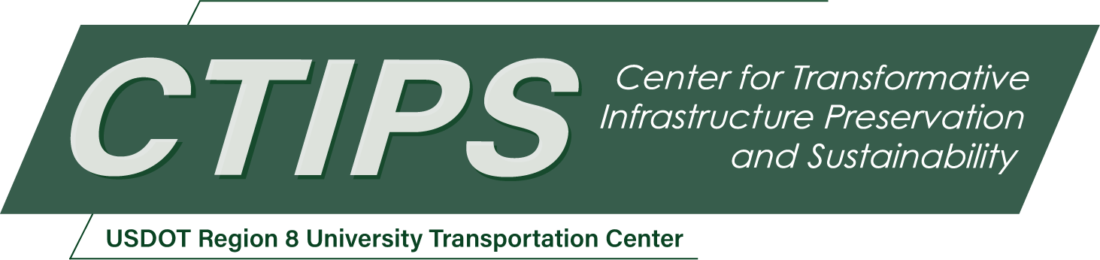

Identifying Gaps in Transit Infrastructure and Potential Solutions
CTIPS-068 – UTC Project Information
Recipient/Grant Number: | North Dakota State University, University of Colorado Denver  Grant No. 69A3552348308
Center Name: | Center for Transformative Infrastructure Preservation and Sustainability
Research Priority: | Preserving the Existing Transportation System
Principal Investigator(s): | Aditi Misra, Ph.D.  Wesley Marshall, Ph.D., P.E.
Project Partners: | USDOT, Office of the Assistant Secretary for Research and Technology – $107,000  Colorado Department of Transportation – $107,000
Total Project Cost: | $214,000
Project Start and End Date: | 1/10/2026 to 1/9/2028

Project Description
A lack of access to transit stops (due to safety concerns, poor first and last mile connections, a lack of shelter to protect from weather elements while waiting, etc.) often presents a significant barrier to using transit services, even when the service itself is well designed. However, for most bus transit projects, the feasibility study at the project planning stage only focuses on a buffer zone of 250 feet around any bus stop, as mandated and required by National Environmental Policy Act (NEPA). Such feasibility studies suffer from two drawbacks: (i) because of the limited spatial extent, they fail to capture the infrastructure gaps that may prevent people from utilizing the services; and (ii) because of limited interaction with current and potential users of the system, they fail to identify user-focused solutions to these gaps. Thus, such feasibility studies may overestimate the potential ridership while also lacking support from the local communities. As Colorado DOT (CDOT) starts implementing its planned bus rapid transit (BRT) services along some of the most heavily traveled corridors within the Denver Metro area, it is important to understand the infrastructure gaps and identify potential solutions to deliver the most benefit possible from our transit infrastructure dollars.
The aim of the proposed project is to identify how and what infrastructure gaps need to be considered before evaluating the success of a transit-related investment. It also aims to create a set of potential solutions for those gaps, through user input of preferences and cost considerations. We use one of the five proposed bus rapid transit projects within Denver Metro area as case study for this proposed project, complementing CDOT’s ongoing work towards the BRT projects. Federal Boulevard BRT, the proposed case study BRT, is planned along one of the most heavily used travel corridors in Denver. The objectives of the project are: (i) to understand the current infrastructure needs to facilitate transit use, such as a lack of bus stop infrastructure, safety concerns, first and last-mile connectivity issues, etc.; and (ii) to identify solutions that best address the needs of the current and potential users. The proposed project will address these objectives through targeted data collection using surveys and app-based travel diary for the BRT catchment area larger than the required feasibility study (using a half-mile buffer around the bus stops instead of 250 feet as done in the NEPA study).

USDOT Priorities
Section left blank until USDOT’s new priorities and RD&T strategic goals are available in Spring 2026.

Outputs
The overarching goal of this project is to provide a generalizable framework that is needed to comprehensively identify infrastructure needs surrounding a transit project for the success of the transit project. CDOT is an active partner in this proposal and the outputs of the project will be used by them for infrastructure and auxiliary service design along the corridor. Beyond publishing findings in peer-reviewed journals and presenting at major transportation and urban planning conferences, we aim to ensure that our methods and results are accessible to a broader audience. We will participate in CTIPS T2 programs in any and either of the three forms of engaging clients and disseminating research results: (i) virtual delivery via live webinars, recorded online modules, videoconferences; (ii) in-person seminars or presentations; and (iii) conferences or workshops that organize related T2 topics into day-long or multi-day events. Additionally, we will structure our data and analysis in an open, non-proprietary format to facilitate collaboration and further research by practitioners, policymakers, and academics.

Outcomes/Impacts
- A final report outlining the findings and guidance for future BRT projects, which will be available in the public domain after approval by CDOT and can be used by other DOTs and transit agencies to design and implement successful BRT projects.
- At least one journal paper and one conference paper to disseminate the research findings and advancements made to the state of the methods used. Currently, there is no such model/methodology that can provide guidance to practitioners on how to choose locations for installing count technologies across a region. This research will fill that gap and provide the first of its kind model for the research community.
- The survey data will be used in a future project with CDOT for travel diary data augmentation using attitudinal data using learning methodologies for better demand prediction models.
- To measure how the proposed BRT project can impact the existing transportation scenario, it is imperative that we collect data on current travel patterns and barriers to intended travel patterns as baseline demand data. Towards that end, targeted community-scale data collection is likely to provide much more granular and ground truth evidence than using outputs from regional travel demand models and can be used for designing more effective transportation supply. This study fills that need for CDOT and creates the baseline data for future follow up studies.
- Although not directly related to the project goals, the proposed project also has potential to create lasting safety impact. Federal Boulevard is one of the major arterials within the high injury network (HIN) of Metro Denver. By identifying the safety issues that undermine transit availability and use, and by proposing infrastructure-based solutions to address those, the study will provide concrete strategies for CDOT and the City to pursue their safety goals and vision.

Final Report
Upon completion, the final report link will be added to the project page on the CTIPS website.

