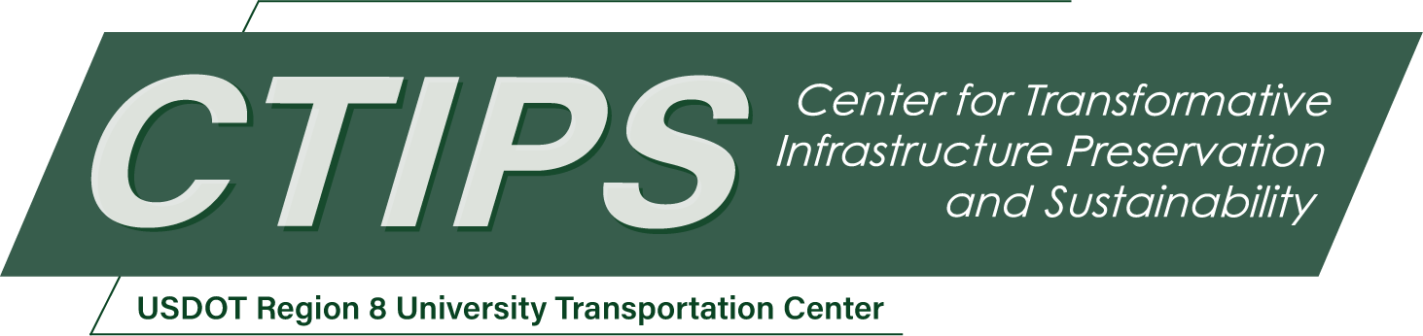

Transportation Workshop: Streets of the Future
CTIPS-069 – UTC Project Information
Recipient/Grant Number: | North Dakota State University, University of Colorado Denver  Grant No. 69A3552348308
Center Name: | Center for Transformative Infrastructure Preservation and Sustainability
Research Priority: | Preserving the Existing Transportation System
Principal Investigator(s): | Manish Shirgaokar, Ph.D.  Aditi Misra, Ph.D.  Wesley Marshall, Ph.D., P.E.
Project Partners: | USDOT, Office of the Assistant Secretary for Research and Technology – $60,000  University of Colorado Denver – $60,000
Total Project Cost: | $120,000
Project Start and End Date: | 1/10/2026 to 1/9/2028

Project Description
With connected and autonomous vehicles (C/AVs), drones, and delivery robots moving from research labs to urban streets, it will not be long before these technologies wind up on city streets. Unfortunately, public and private transportation stakeholders are generally not suited to keep up with technological change, especially when multiplier effects from various strands of innovation can disrupt urban life. Therefore, there is an urgent need to train a future-focused workforce that can adapt from today’s best practices and standards, be creative and critical, and come up with innovative options for road safety in the future. Likewise, there is an urgent need to demonstrate to public/private sector stakeholders the most likely transportation changes and challenges over the next two decades. This project has two aims: i) offer a new graduate-level course focused on using urban corridors as test beds to imagine reasonably accurate future scenarios that are based on state-of-the-art knowledge from the current times, and ii) to assemble an exhibition where the lessons learned will be shared more broadly with the transportation community through a virtual environment (VR) and posters.

USDOT Priorities
Section left blank until USDOT’s new priorities and RD&T strategic goals are available in Spring 2026.

Outputs
The main pedagogical activities will include existing-condition analyses, scenario modeling by leveraging and critiquing current design guides with a focus on road safety, and the production of visualized redesign concepts. A central technology transfer innovation of this project is the development of a virtual reality (VR) plus poster/banner-based traveling exhibition that showcases student-designed urban corridors in 2050. This traveling exhibition will serve both as an educational tool for stakeholders and as an outreach platform to agencies, practitioners, and the broader public. By translating technical design outputs into immersive and visual formats, the project will aim to expand the impact from a classroom setting and strengthen connections between education, workforce development, and communities in the Denver Metro Region. Mainly, we envision the exhibition being on-site with stakeholders in state and local government agencies such as the Colorado Dept. of Transportation (CDOT), Denver Regional Council of Governments (DRCOG), City & County of Denver’s Department of Transportation and Infrastructure (DOTI), and consulting firms.

Outcomes/Impacts
- New Multidisciplinary Course Offering: Launch a graduate-level design workshop that integrates urban planning and transportation engineering focusing on road safety.
- Enhanced Student Skillsets: Students gain hands-on experience in multimodal design, scenario planning, and policy, which are critical skills for future transportation careers.
- Workforce Readiness: Graduates will be better prepared to work in public agencies, consulting firms, and tech-driven transportation sectors, with practical knowledge of national design standards (MUTCD, NACTO, PROWAG, or AASHTO).
- Exposure to Emerging Technologies: Students will engage with concepts such as road safety, automated vehicles, dynamic curb management, and freight innovations, preparing them for future infrastructure needs.
- Strengthened Industry-Academic Partnerships: Collaboration with transportation agencies and firms will provide feedback on student work and create pathways for internships and employment.
- Scalable Educational Model: Course materials and outcomes will be documented for replication at other UTC-affiliated institutions, contributing to national STEM education reform.
- Long-Term Impact on Transportation Education: The course will serve as a model for integrating design thinking and multimodal planning into STEM curricula, fostering innovation and leadership in the next generation of transportation professionals.

Final Report
Upon completion, the final report link will be added to the project page on the CTIPS website.

