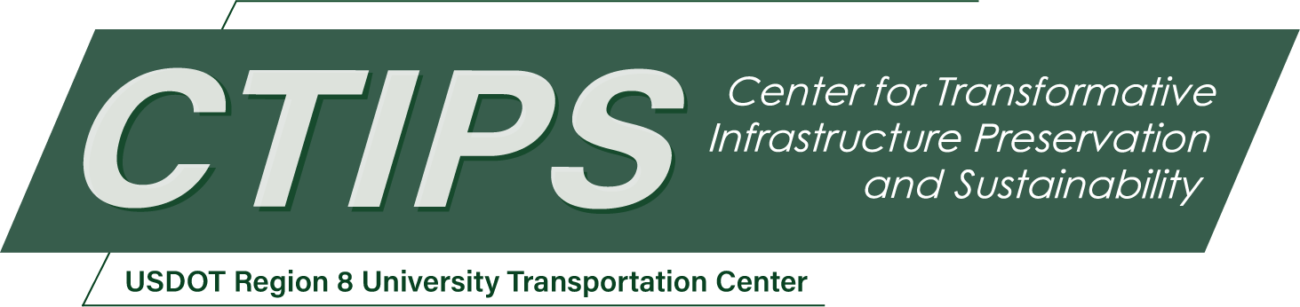

Comparing Traffic Safety Risks Across Transportation Modes
CTIPS-070 – UTC Project Information
Recipient/Grant Number: | North Dakota State University, Utah State University  Grant No. 69A3552348308
Center Name: | Center for Transformative Infrastructure Preservation and Sustainability
Research Priority: | Preserving the Existing Transportation System
Principal Investigator(s): | Patrick A. Singleton, Ph.D.
Project Partners: | USDOT, Office of the Assistant Secretary for Research and Technology – $70,000  Utah LTAP – $70,000
Total Project Cost: | $140,000
Project Start and End Date: | 3/22/2026 to 3/21/2028

Project Description
This research project compares traffic safety risks across different transportation modes. Very few studies have quantified crash risk across modes, especially recently in the United States. First, this study will calculate and compare mode-specific crash rates, using data from Utah and potentially elsewhere. Second, these mode-specific crash rates will be adjusted for key traffic safety risk factors, about the locations where and times when crashes take place, and the people who are involved. Finally, this work will propose a research-informed framework and analytical methods for improved comparisons of traffic safety risks across transportation modes, especially considering the contexts, factors, and mechanisms of crash causation. Overall, this research will generate useful traffic safety performance measures to help with prioritizing transportation safety investments and communicating safety risks to the public.

USDOT Priorities
Section left blank until USDOT’s new priorities and RD&T strategic goals are available in Spring 2026.

Outputs
Outputs from the project will include: a peer-reviewed research report, two peer-reviewed journal articles and/or conference papers, multiple research presentations, datasets, and analysis scripts. The research report (and a brief) will be published on the CTIPS website and archived in USDOT’s ROSAP repository. Manuscripts will be submitted to academic journals, and presentations will be given at local, national, and/or international conferences such as meetings of the Utah Department of Transportation and the Transportation Research Board. Datasets and analysis scripts will be published on the PI’s GitHub page and archived in an open-science repository such as Zenodo. These research outputs will also be shared more widely with relevant practitioners through emails and social media posts.

Outcomes/Impacts
The calculation and comparison of mode-specific crash rates is expected to improve the practice of traffic safety management. Even the work linking crashes to mode-specific exposures (to enable such a comparison) is a challenging task that is currently lacking at most transportation agencies. Besides providing new and useful traffic safety performance measures (mode-specific crash rates), this project will also show agencies how to assemble the required data and perform the necessary calculations. DOTs and other organizations can use this information for prioritizing traffic safety investments, as well as when communicating with the public about traffic safety risks. For instance, easy-to-understand online dashboards could be created, showing the relative traffic safety risks in different places or times-of-day.
This project will also have positive impacts on traffic safety research practices, through the development of a proposed framework and methods for considering crash causation mechanisms. The organization of existing knowledge on multimodal traffic safety risk factors and relationships into a conceptual framework will aid future researchers and practitioners when planning safety data collection efforts. Also, the integration of methods from causal inference will help future scholars improve their research approaches to produce more accurate and actionable findings to inform traffic safety policy.

Final Report
Upon completion, the final report link will be added to the project page on the CTIPS website.

