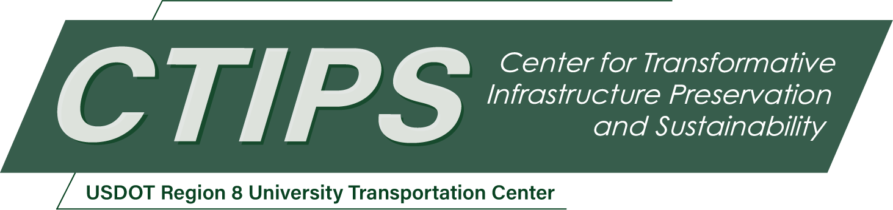

Transforming Transportation with an Innovative and Talented Workforce: A Transportation Careers Workshop
CTIPS-071 – UTC Project Information
Recipient/Grant Number: | North Dakota State University, University of Denver  Grant No. 69A3552348308
Center Name: | Center for Transformative Infrastructure Preservation and Sustainability
Research Priority: | Preserving the Existing Transportation System
Principal Investigator(s): | Patrick Sherry, Ph.D.
Project Partners: | USDOT, Office of the Assistant Secretary for Research and Technology – $38,970  Truckload Carriers Association – $18,970  University of Denver Supply Chain Institute – $5,000  Gallegos Consulting, Inc. – $5,000  United Parcel Service – $5,000
Total Project Cost: | $77,940
Project Start and End Date: | 3/22/2026 to 3/21/2028

Project Description
The proposed event will be a two-day workshop in Durango, Colorado, at both Fort Lewis College and another community site or high school, featuring several key presentations and a panel discussion. The first day will consist of speakers and presentations. The second day will consist of interactive feedback at separate locations regarding the results of vocational assessment inventories. The target population of workshop participants will be high school and college students interested in learning more about careers in the transportation industry. Participants will complete surveys and career-planning instruments and receive detailed interpretations of their results to help them narrow their career choices. Representatives from trucking, transit, state DOTs, and the supply chain industry will be invited to participate as experts, delivering presentations that describe careers and opportunities in the transportation industry. In addition, there will be an interactive session to help participants prioritize their vocational interests and preferences. Lastly, a networking event with presenters will also be arranged.
In addition to providing career information on activities, salaries, and other employment and career opportunities in the transportation industry, the proposed workshop will also address two main needs regarding the recruitment of potential entrants to the transportation industry. First, identify a transportation career profile for prospective applicants to target highly congruent candidates for the industry. This profile will provide researchers with an opportunity to develop an interest and preference profile of prospective students whose interests are congruent with the industry. Identifying those persons who are likely to be congruent allows outreach efforts to be tailored and targeted, and limited funds and resources to be used more effectively. Second, a short, easy-to-use web page that could assist students in obtaining information about transportation careers in general, with a brief survey or questionnaire to help narrow down interests in transportation careers, which then directs users to more targeted information. This web page could then be made available to other UTC programs that conduct transportation and career outreach events. The web page will be used to tally hits, and requests for applications will help more accurately measure the impact of the workshop's outreach efforts. This outreach project will also incorporate the development and implementation of a prototype webpage to evaluate the workshop and serve other UTCs.

USDOT Priorities
Section left blank until USDOT’s new priorities and RD&T strategic goals are available in Spring 2026.

Outputs
The results of the work performed will most likely lead to an increase in the number of college graduates who apply for and accept a position in the transportation sector. The outcome of more applicants and acceptances into positions will likely be a greater number of skilled professionals.

Outcomes/Impacts
The expected outcome of the workshop is to increase the number of students interested in transportation careers, who will likely continue to devise and develop innovative and transformative solutions to the congestion challenges facing the transportation sector.
To increase the likelihood of success for these and subsequent workshops in attracting and retaining entrants to transportation careers, a profile of workshop attendees who express a high degree of interest in pursuing transportation-related jobs will be generated based on their interests and preferences. A Transportation Career Profile (TCP) would benefit numerous academic programs and UTCs engaged in this type of outreach. A TCP could help recruit and target potential participants in transportation career outreach efforts.
A critical need is the development of a centralized web page for identifying careers and occupations in the transportation industry, which can then provide guidance to other, more specific training and application portals. As part of the proposed workshop, here is the development of a centralized web page that can be offered to participants, prospective students, and prospective job seekers or applicants. This could lead to the implementation of a short, easy-to-use mobile phone-based app that assists students in obtaining information about transportation careers in general, with a concise survey or questionnaire that helps narrow down interests in transportation careers and then directs users to more targeted information. As part of this outreach project, a prototype webpage will be developed and evaluated with the workshop participants.
Ultimately, the outcome will be to continue to sustain and enhance economic growth, to compete globally, and to improve the efficiency, safety, and/or cost-effectiveness of the transportation system through the development and commercialization of new technologies and practices. This will be achieved by having highly skilled, motivated, and competent college graduates enter transportation careers and positions.

Final Report
Upon completion, the final report link will be added to the project page on the CTIPS website.

