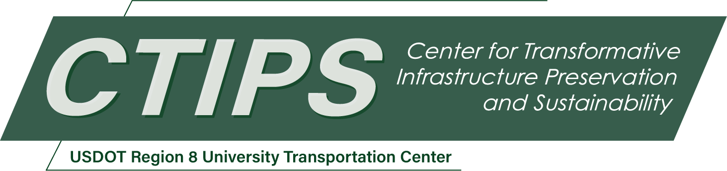

Anchorage Design and Detailing for Fabric-Reinforced Cementitious Matrix Retrofits of Transportation Concrete Structures
CTIPS-072 – UTC Project Information
Recipient/Grant Number: | North Dakota State University, South Dakota State University  Grant No. 69A3552348308
Center Name: | Center for Transformative Infrastructure Preservation and Sustainability
Research Priority: | Preserving the Existing Transportation System
Principal Investigator(s): | Akram Jawdhari, Ph.D., P.E.
Project Partners: | USDOT, Office of the Assistant Secretary for Research and Technology – $64,999  South Dakota State University – $58,083; Simpson Strong Tie – $5,000; KYOWA Co. – $5,000; Fyfe Co. – $2,000; ACI NEx – $1,500
Total Project Cost: | $136,582
Project Start and End Date: | 3/22/2026 to 3/21/2028

Project Description
The repair and rehabilitation of transportation structures is urgently needed to restore structural capacity, slow deterioration caused by aging, overloading, and environmental stressors, and minimize disruptions associated with large-scale replacement projects. State DOTs and FHWA have implemented several advanced rehabilitation techniques, including fiber-reinforced polymer (FRP) composites, ultra-high-performance concrete, and fiber-reinforced cementitious matrix (FRCM) systems. FRCM consists of an open-grid textile made of FRP or steel strands embedded within an inorganic cementitious matrix. The system offers multiple advantages over traditional FRP, including mechanical compatibility with concrete and masonry substrates, improved fire and elevated-temperature performance, vapor permeability, durability in moist or cold environments, and ease of application in field conditions.
As an externally bonded strengthening system, the performance of FRCM is governed by the ability of the FRCM–substrate interface to maintain composite action and to transfer forces effectively. Premature interfacial slip, end debonding, or localized interface damage are commonly reported for unanchored FRCM systems. These brittle failure modes often occur at loads far below the tensile capacity of the textile, limiting the effectiveness of the strengthening system to 30–60% of its potential and undermining both safety and return on investment. Introducing anchorage mechanisms into FRCM systems provides an engineered means to restrain interfacial slip, delay debonding, promote more favorable failure modes, and enable the textile to mobilize higher tensile strains. However, the existing literature on FRCM anchorage is sparse, fragmented, and lacking in unified, design-oriented guidance. Quantitative provisions addressing anchor geometry, capacity, and interaction with the primary FRCM reinforcement remain absent from current codes and standards.
The primary objective of this research is to advance the understanding, design, and implementation of anchorage systems for FRCM-strengthened concrete members, with the goal of mitigating premature debonding and achieving ductile, and efficient strengthening outcomes. Specifically, the project aims to: (a) synthesize and critically evaluate the current state of knowledge on FRCM anchorage; (b) develop and experimentally validate practical anchorage systems including transverse wraps, mechanical anchors, and spike anchors; and (c) produce a design-oriented framework for selecting, proportioning, and detailing anchorage systems.
Two coordinated experimental programs are proposed: (1) bond-level tests to characterize the effects of anchorage presence and type on joint force transfer, slip response, and failure mechanisms; and (2) flexural tests on reinforced concrete beams strengthened with anchored and unanchored FRCM reinforcement, to evaluate the translation of bond-level behavior to member-level performance and to verify design expressions under combined shear and normal stresses. The proposed research will equip state DOTs with validated anchorage solutions, support cost-effective preservation strategies, and accelerate the adoption of durable composite materials for extending the service life of transportation infrastructure.

USDOT Priorities
Section left blank until USDOT’s new priorities and RD&T strategic goals are available in Spring 2026.

Outputs
The project findings will be disseminated and transferred to researchers, professionals, and practitioners through a variety of methods, including peer-reviewed articles that detail experimental and analytical results alongside practical recommendations. Workshops and live webinars hosted by CTIPS and professional events, such as research-in-progress sessions during the American Concrete Institute (ACI) bi-annual conventions and the Transportation Research Board (TRB) meetings, will further extend outreach. The research outputs will also be shared via university and CTIPS web pages, as well as professional platforms like LinkedIn. Engagement with design professionals, bridge authorities such as State DOTs and FHWA engineers, and industry leaders, including committee chairs and chapter directors from the ACI and TRB, will be prioritized to support the transformation of research findings into practice.

Outcomes/Impacts
The proposed research is expected to deliver a consolidated understanding of FRCM anchorage behavior and provide validated, design-oriented tools for improving the performance of FRCM retrofits in transportation infrastructure. Key outcomes include improved reliability of FRCM systems, reduced likelihood of brittle debonding failures, and enhanced utilization of high-performance textiles. Addressing the stated research gaps, the project will support more efficient and economical retrofit designs and facilitate broader adoption of FRCM technology by transportation agencies and practitioners, contributing to extended service life, improved safety, and reduced life-cycle costs of aging infrastructure. The findings will also establish a foundation for future research, including field implementation studies, long-term durability assessments, and potential integration of anchorage provisions into national design guidelines and standards.

Final Report
Upon completion, the final report link will be added to the project page on the CTIPS website.

