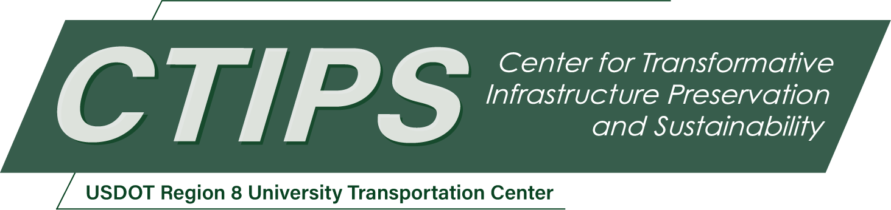

Project Title Goes Here
CTIPS-### – UTC Project Information
Recipient/Grant Number: | North Dakota State University  Grant No. 69A3552348308
Center Name: | Center for Transformative Infrastructure Preservation and Sustainability
Research Priority: | Preserving the Existing Transportation System
Principal Investigator(s):
Project Partners: | USDOT, Office of the Assistant Secretary for Research and Technology – $  List additional fund source(s) here…
Total Project Cost: | $
Project Start and End Date:

Project Description
Project abstract goes here…

USDOT Priorities
Section left blank until USDOT’s new priorities and RD&T strategic goals are available in Spring 2026.

Outputs
The results of the work performed. Describe what new research, technology, or process this research project is expected to produce or has produced. The outputs could include processes and methods; data, hardware, software and databases; invention disclosures, patent filings, inventions, etc. Also describe any new partnerships outside of the UTC consortium that may be established or have been established through the project.

Outcomes/Impacts
Describe the application of the output and any changes this output has or will make to the transportation system, or its regulatory, legislative, or policy framework, including a description of products or patents, or a change in practice, or instances of research results informing policy decisions. Discuss how this research output will positively impact the transportation system in terms of safety, reliability, durability, costs, etc.

Final Report
Upon completion, the final report link will be added to the project page on the CTIPS website.

